**Purpose of SRTSWeb**

The mission of the Spectacle Request and Transmission System web (SRTSweb) is to support the need for a clinically integrated, secure web-based application to support the Military Health System Optical Fabrication Enterprise (OFE). SRTSweb fulfills the requirement of the OFE’s mission to support military readiness worldwide by providing a means for optometry clinics to create, submit, and track eyewear orders for spectacles, protective, and other combat lenses. SRTSweb is used by clinics and labs for Army, Navy, Air Force, Coast Guard, Veteran Administration Hospital, Federal Detainees, Public Health Service, Department of State, Department of Indian Affairs, ROTC cadets, as well as other humanitarian missions.

SRTSweb comprises a clinic and lab client applications, and a G-EYES application that Warfighters serving in theaters worldwide can use to re-order eyewear.

There are several benefits in using SRTSweb in the medical readiness field. Because SRTSweb is a web-based application it eliminates the need for client application software, satisfies the Tri-Service Information Assurance (IA) requirements, and provides the user with a state-of-the-art tool to accomplish the mission.

Additionally, there is no application specific hardware to maintain, no software to install, and no application software updates. There will be little or no impact to the user during server upgrades, maintenance, or back-ups. The user will type in an address in the URL field of an Internet browser, or save it to their Favorites drop-down menu in their Internet browser for easy access. SRTSweb ends the need for the application to be hosted and managed at each clinic location. This action is accomplished by centralized servers that provide for less local site management in support of the application, resulting in reduced support requirements on the end users.

**LOGGING INTO SRTSweb**

<https://srtsweb.amedd.army.mil/>

Type in the SRTSweb URL to access the application.  The first screen displayed in the application is the SRTSweb User Agreement screen.  Read and accept the SRTSweb User Agreement to proceed.

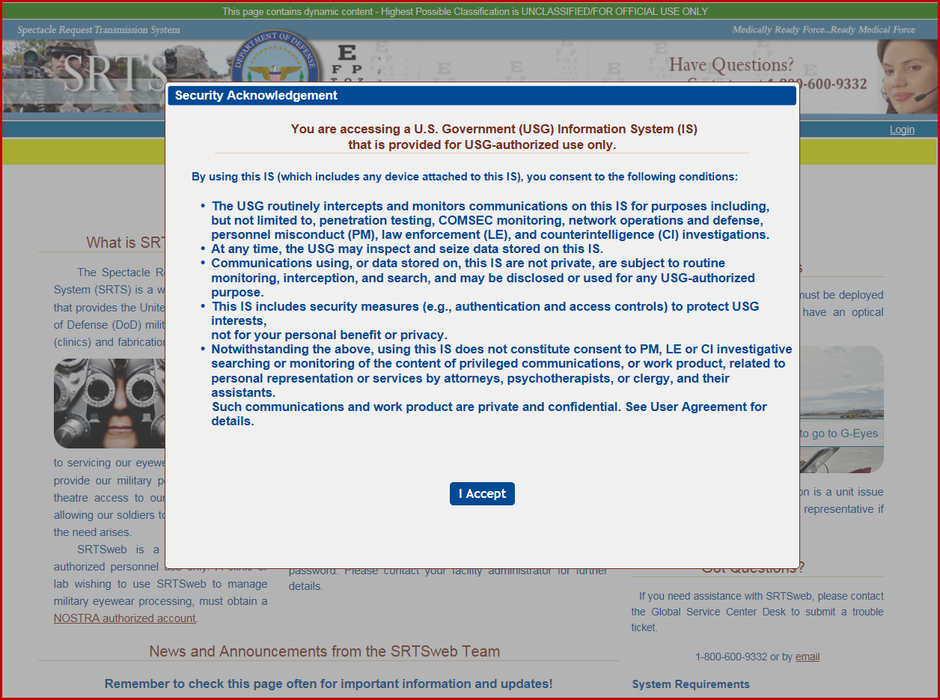

The screen will display the welcome and log in screen of SRTSweb. If the user **does not** have an account with Legacy or SRTSweb press the “**Request New Site/Facility**” link and the Facility Account Request Form will appear. Complete the registration form and click the Submit button. An email notification will be sent to the requester email provided once the account is created by the Naval Ophthalmic Support & Training Activity (NOSTRA).

If the user **does** havean account with Legacy or SRTSweb and needs system access press the “**Request System Access**” link.

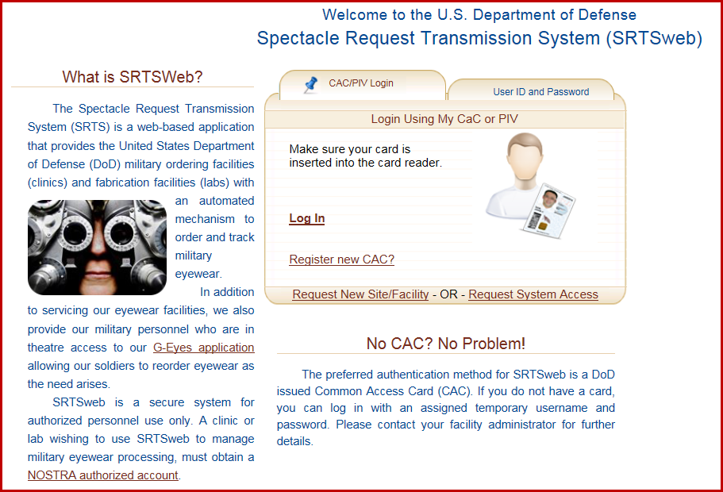

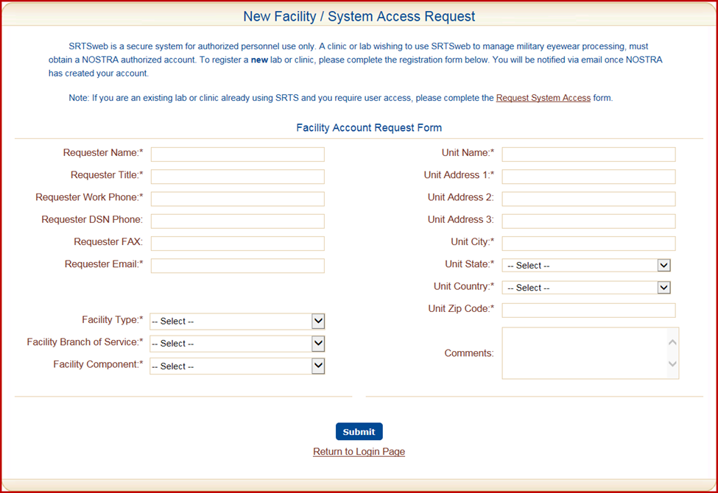

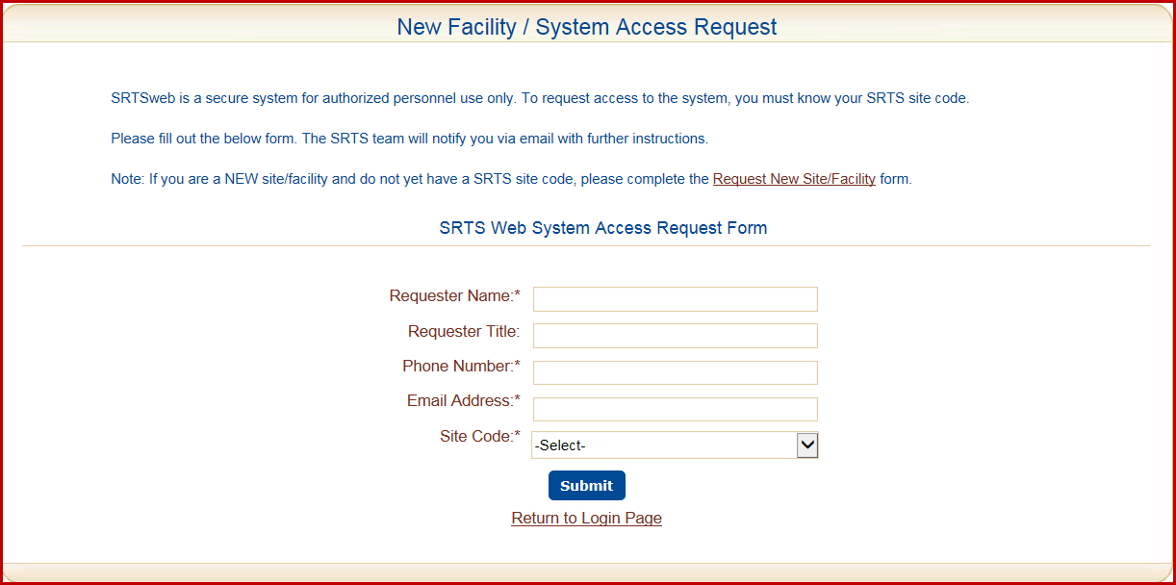

The user will get a message stating the request was successful.



On the Welcome page there is a link to the G-Eyes Orders module. The user must be at a deployed APO/FPO/DPO, have an APO/FPO/DPO zip code and have an order on file to use G-Eyes. No login is needed to use G-Eyes.

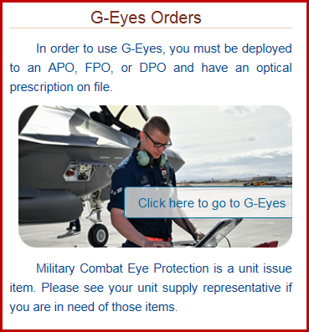

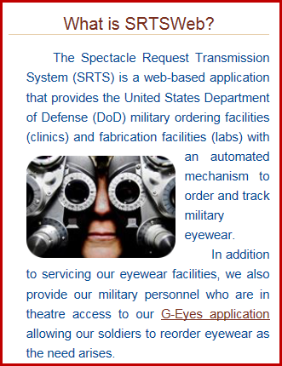

At the bottom of the welcome and login page there is a section for “News and Announcements from the SRTSweb Team”. Remember to check this page often for very important information and updates from the SRTSweb team and the user’s administrative section.

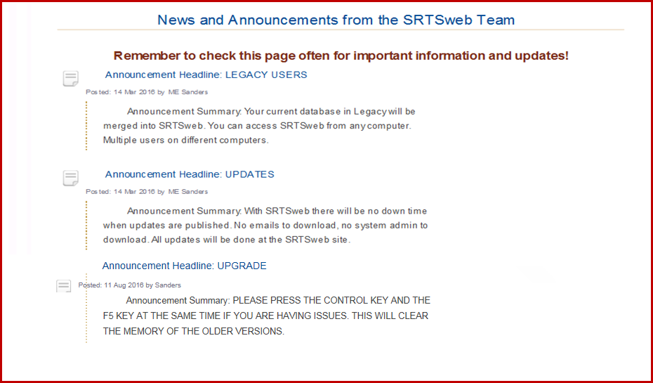

Support for customers of the SRTSweb system will come directly from SRTSweb team members located at DHA Clinical Solutions – Army South. The request for support should be submitted via the Global Service Center Desk located at DHA.

For assistance with SRTSweb, please contact the Global Service Center Desk by phone at 1-800-600-9332 or by email at: [dhagsc@mail.mil](mailto:dhagsc@mail.mil) to create a support ticket.

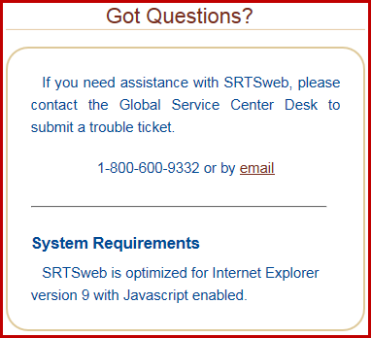

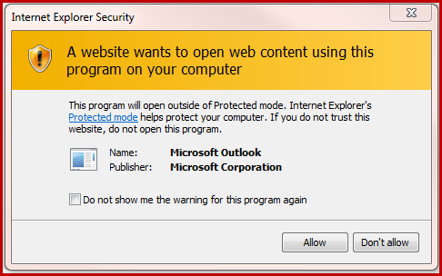

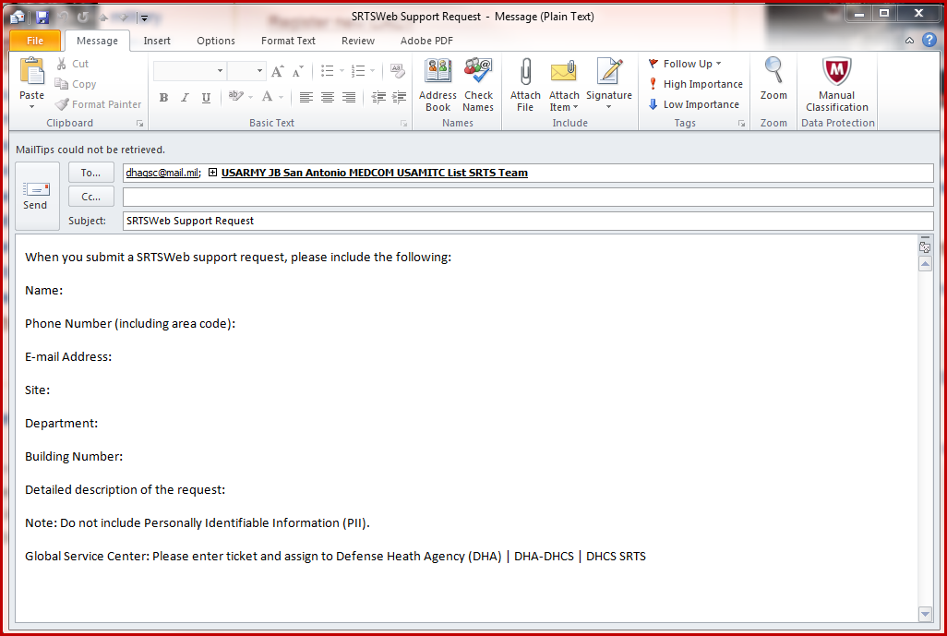

The screen has a **Check Order Status** for patients to track their orders. The patient does not have to log into SRTSweb.

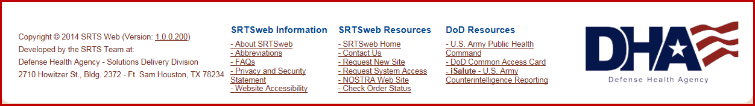

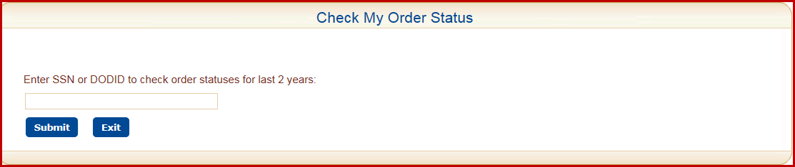

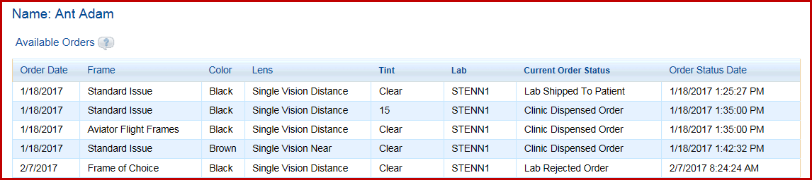

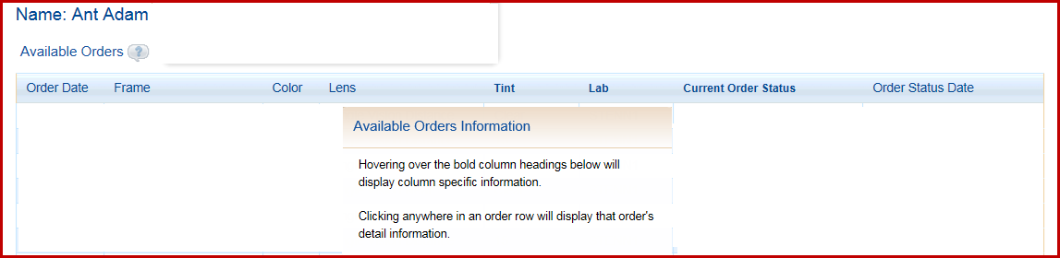

After accepting the User Agreement screen the welcome and log in screen of SRTSweb will appear. Must log in with their CAC.

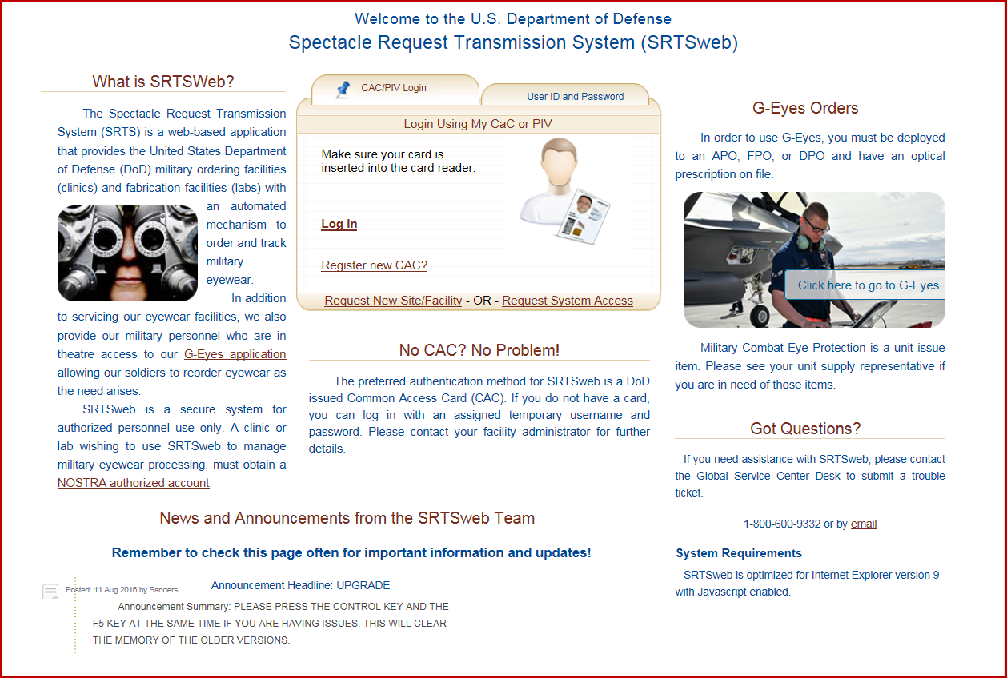

When user is logging in with CAC use the Non-Email certificate to log in as an Admin. Use the Email certificate to log in as a lab tech or clerk.

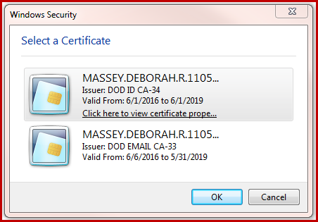

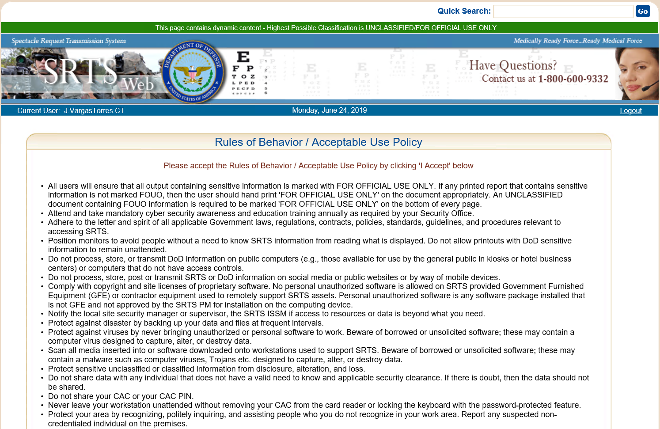

Admin users have a session time out of 10 minutes.

Users will see Logout Warning at the 5 minute warning. Pressing anywhere on the screen will continue the session for the user.

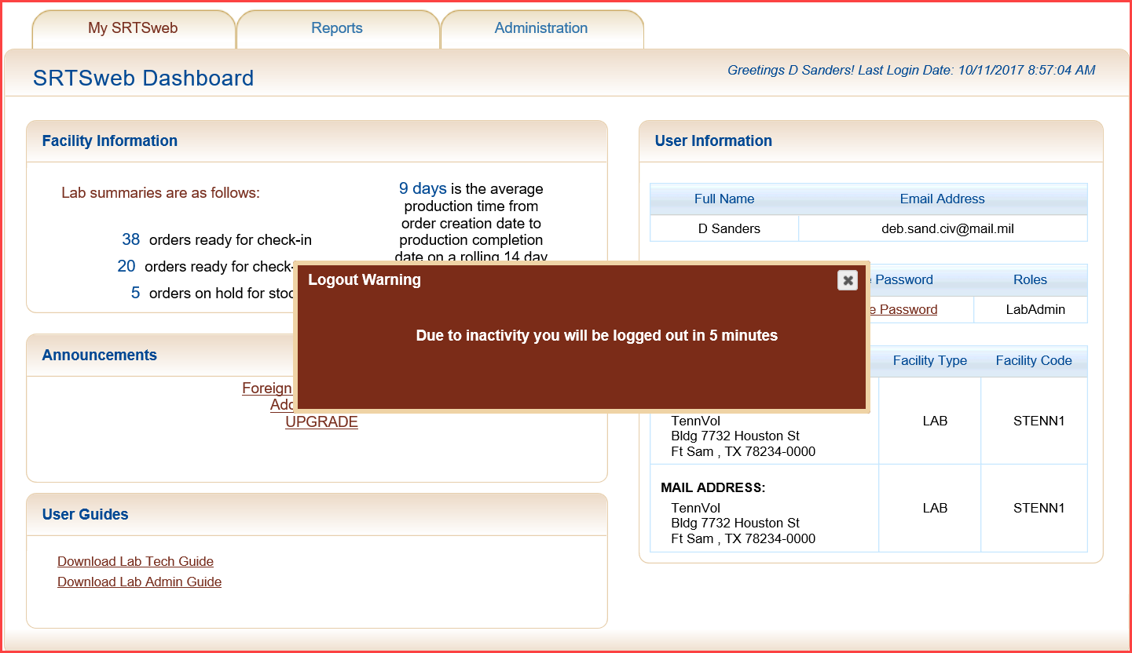

Users will automatically be logged out if the screen is not touched either at the 5 minute warning or within 10 minutes.

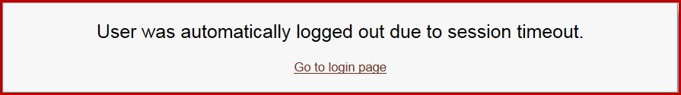

Users will have the following message if the Logout is pressed to exit the application.

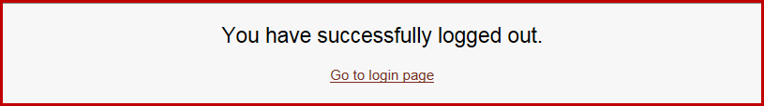

# SRTSweb Dashboard

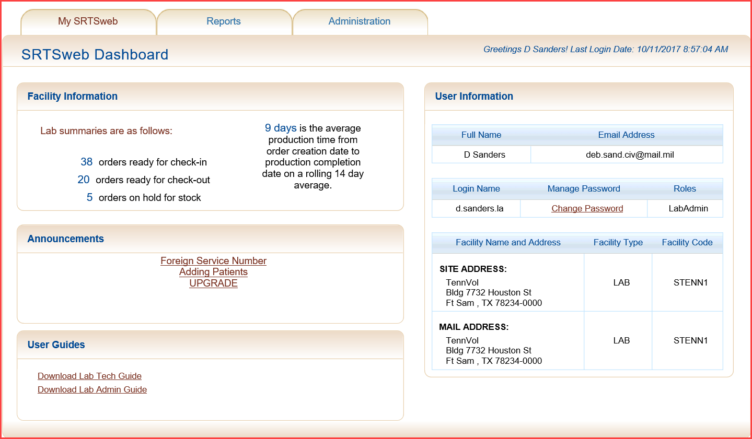

Once logged into the system as a user with Lab Administrator privileges, the screen contains a title bar and a menu of tabs, My SRTSweb, Reports and Administration.

On the right side of the title bar is a link to logout of the SRTSweb application.

The dashboard shows the current Username. The dashboard also shows the user with the last successful login date and time prior to the current log on session on the right.

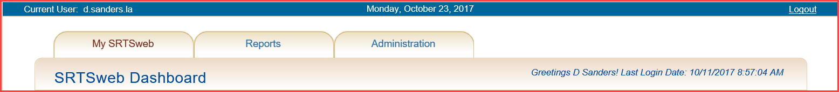

Directly below the tabs, the My SRTSweb Dashboard is displayed. The Dashboard can be accessed by selecting the My SRTSweb tab from anywhere in the application. The Dashboard can also be accessed by pressing the SRTSweb logo.

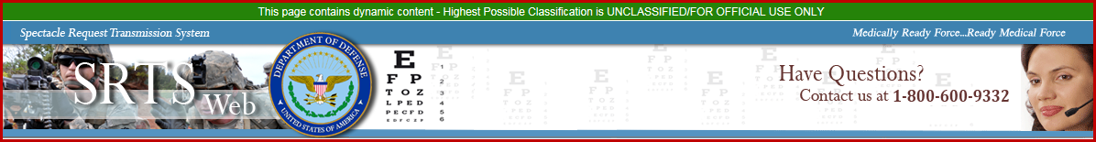

The Dashboard is composed of 4 sections: Facility Information, Announcements, User Guides and User Information.

## 

## Facility Information

For users logging in with the Lab Administrator role, on the left side of the Dashboard, a section called Facility Information is displayed which contains Lab Summaries.

### Lab Orders Summary

The Lab Orders Summary shows totals of the site’s orders by status to include:

* Ready for Check-In
* Ready to Check-Out
* Hold for Stock

Also shown is the average production time for order production.

The three summaries are for information only.

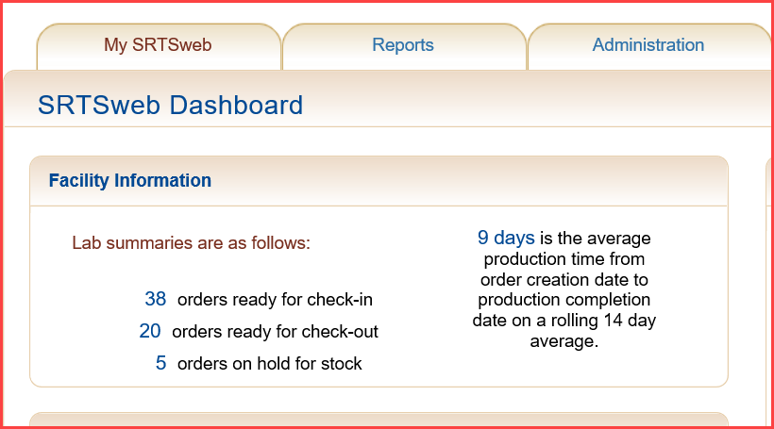

**Announcements**

Announcements can be viewed from this screen. The same message can be viewed under My SRTSweb - My Message Center.

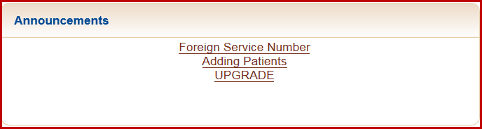

**User Guides**

For users logging in with the Lab Administrator role User Guides for the Lab Admin and the Lab Tech can be downloaded from this screen.

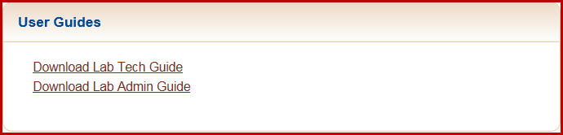



## User Information

On the right side of the Dashboard is the profile information section which displays user profile information. Included in the login information is the user’s Full Name, Email Address, Login Name, a link to Manage Password and the user’s assigned Role(s). This section also contains the Facility Name and Address, Facility Type, Facility Code and user’s mailing address.

The site administrator is the only user who can update the user demographic and login information except for login name.

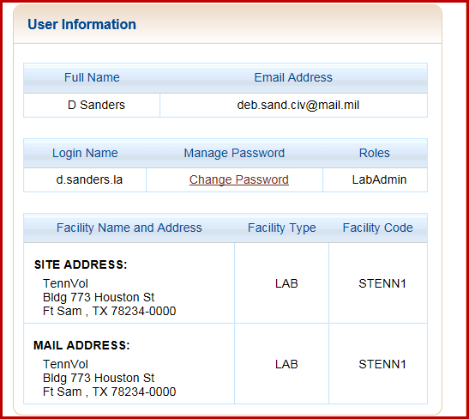

A user can change his or her password here. Once the CAC is registered the password is no longer needed.

The user must change at least eight (8) characters in the password.

The system prohibits the reuse of the last five (5) passwords.

The password has a minimum lifetime of twenty four (24) hours.

The password can only be changed after 24 hours of previous change.

User passwords expire every 90 days. Passwords requirements are:

* Minimum of 15 characters long
* 2 upper case characters
* 2 lower case characters
* 2 numbers
* 2 special characters! @ # $ % ^ & * ( )

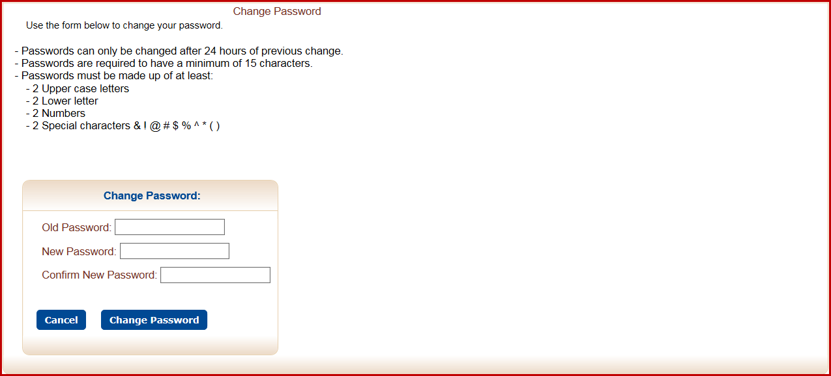

After changing the password a confirmation message is displayed.

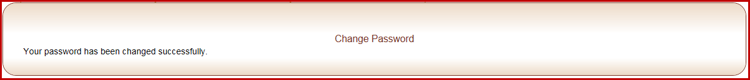

Press My SRTSweb to go back to dashboard.

**My SRTSweb**

If the cursor pointer is moved to the My SRTSweb tab above the SRTSweb Dashboard title, two links are provided on the drop down menu. To access announcements or messages click on the My Message Center option. To access the Release Notes click on the Release Notes option.

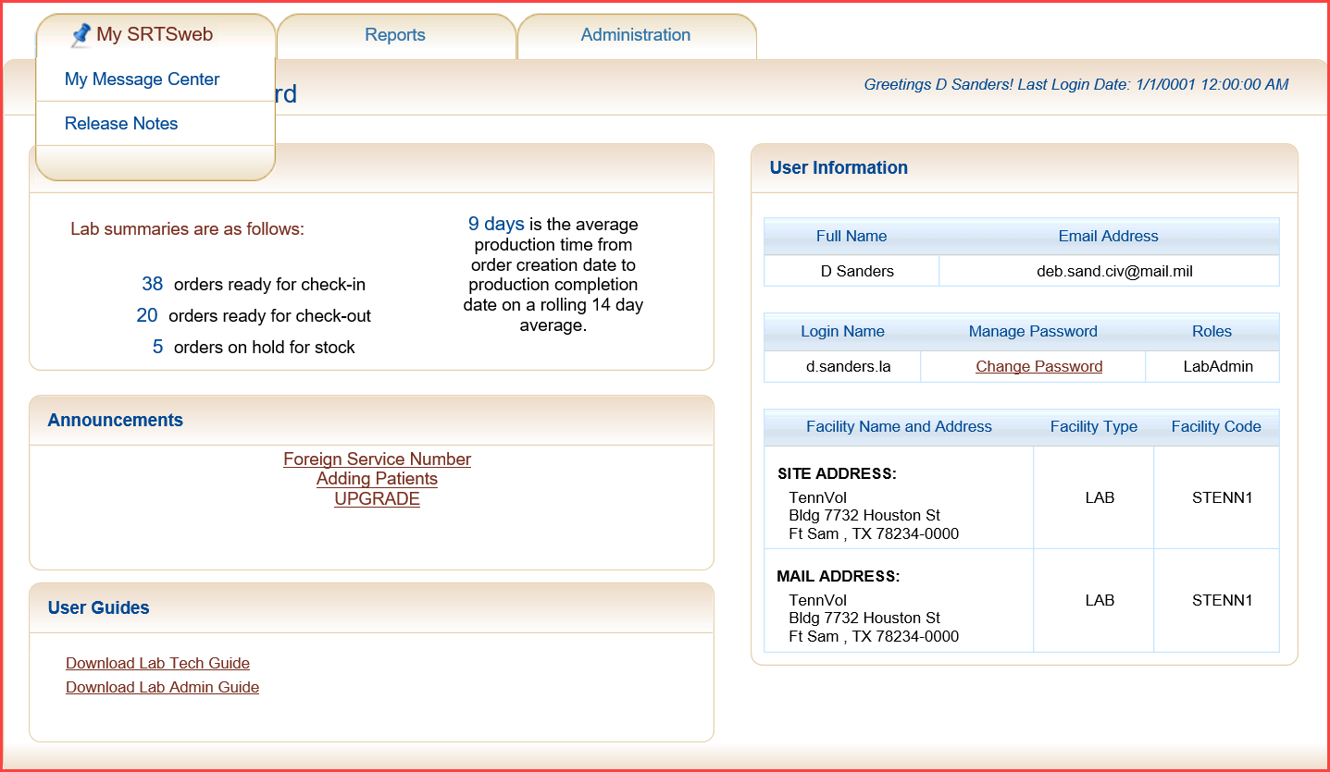

## My Message Center

Message Center is a place that users with CMS level privileges post messages or announcements. They can be viewed under Messages or on the left under Summaries on the SRTSweb Dashboard screen.

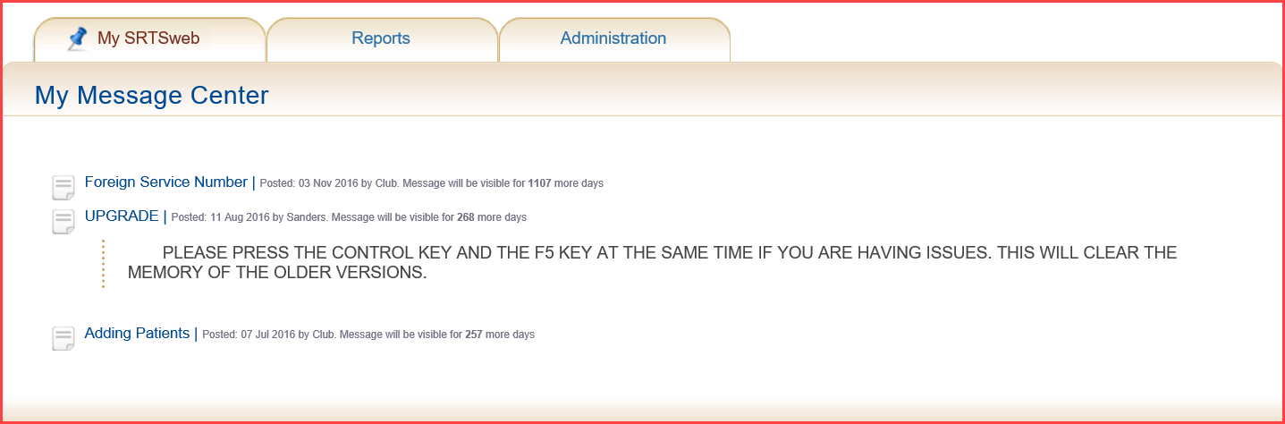

Messages and announcement posted in My Message Center are entered through the Content Management System (CMS) Manager module of the SRTSweb application. This function allows users with CMS level privileges to enter, post, and manage messages and announcements. For more information on CMS, please see the section on Administration – CMS Manager in this User Guide.

## Release Notes

Release Notes will show the latest updates to the system.

To view release notes for the current SRTSweb version, select Release Notes from the My SRTSweb drop down menu. Users can also click on the version number at the bottom of the Dashboard screen to see release notes.

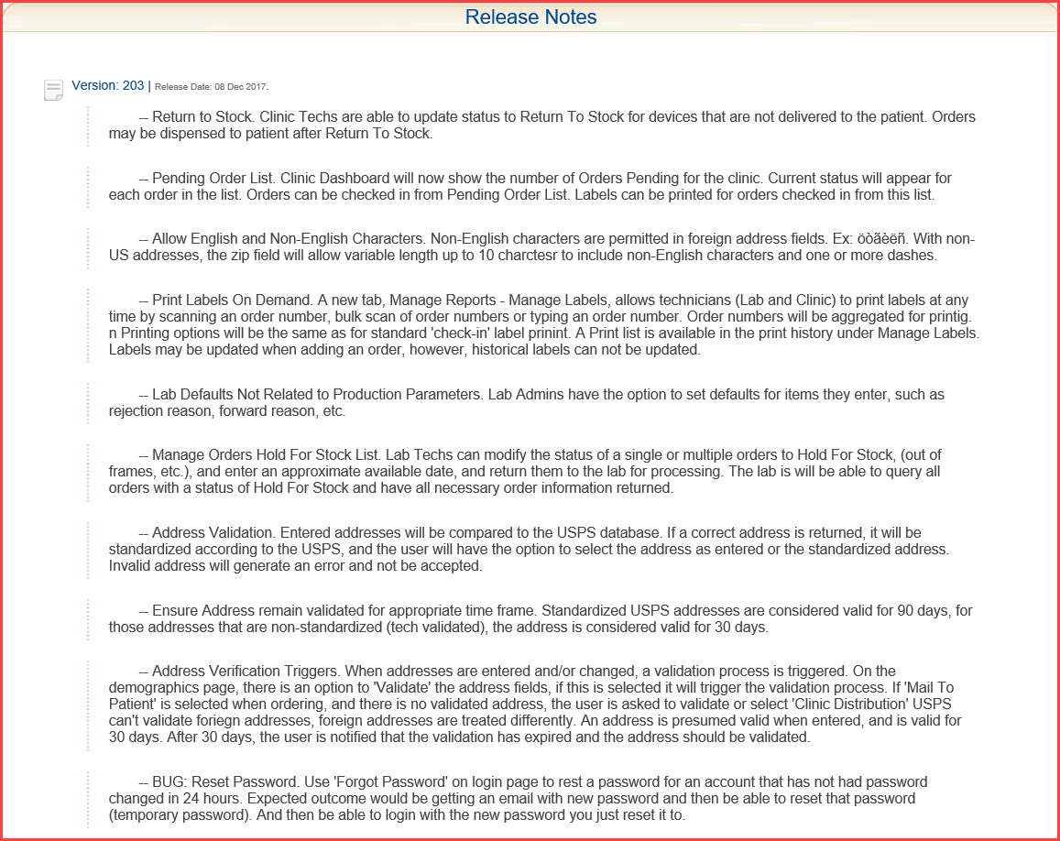

To go back to dashboard press either the back arrow or the link SRTSweb Home at bottom of page. User can also press on the SRTSweb logo at the top on the left from anywhere in the app to return to dashboard.

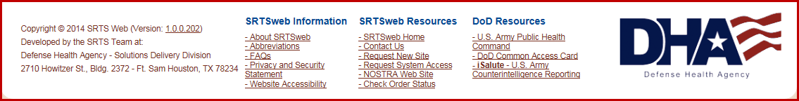

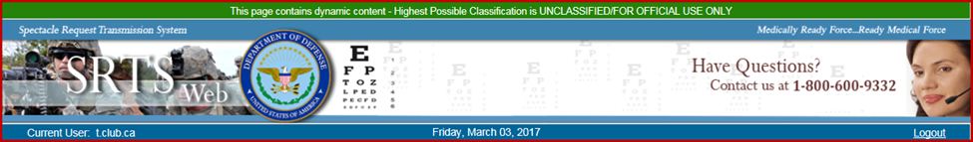

## Reports

The user has the option to select a report from the drop down list in the Select a Report to View field.

# 

## Manage Reports

The user has the option to select a report from the drop down list in the Select a Report to View field.

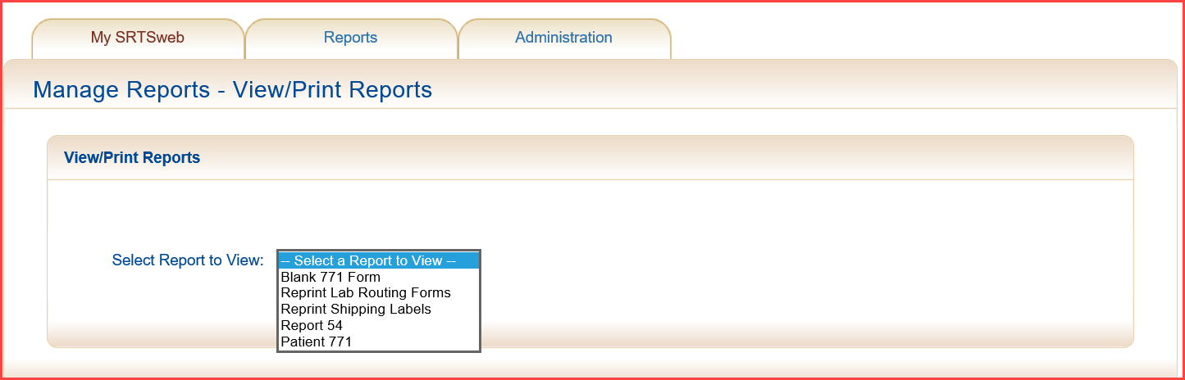

**NOTE: Mailing label can be reprinted under Reports – Manage Report – Reprint Shipping Labels. The reprint option is good for 7 days.**

**This option print all the labels from selected list.**

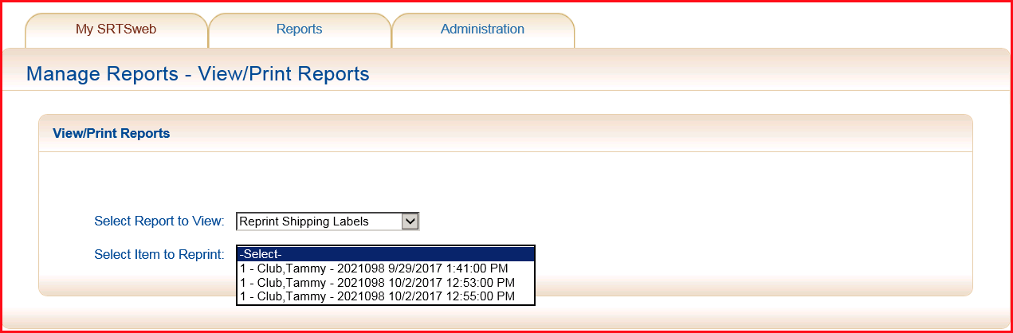

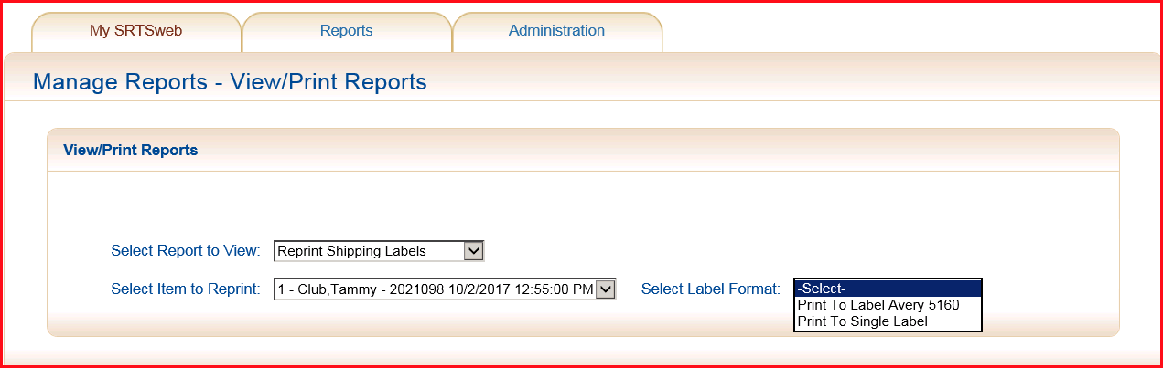

To view the Form 54 report select the From Date and the To Date by selecting a date from the calendar or by entering a date range. Dates entered manually must in be the format: *mm/dd/yyyy*.

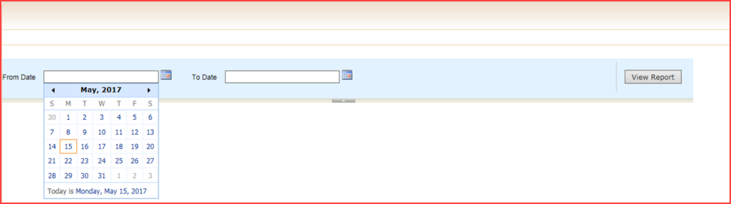

Once the selected report is displayed it can be saved in these formats:

* XML file
* CSV file (comma delimited)
* MHTML (web archive)
* Microsoft Excel file
* TIFF file
* Microsoft Word file

To save or print the report, move the mouse pointer above the Export drop down menu and select the file type desired from the drop down list. The user is asked to choose between opening the report and saving it to disk. If opening the report, the Adobe program (Adobe Reader, Adobe Acrobat, or Adobe PDF Converter) can be used to display the report. If the report is to be saved to disk, it will be downloaded to the user’s PC.

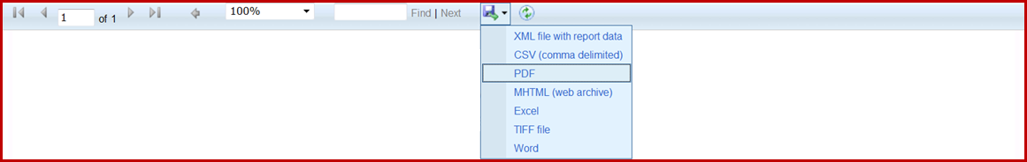

The user can open, save or cancel the report. Print reports from here.



Report samples can be viewed at the end of the SRTSweb Lab User Guide.

## Manage Labels

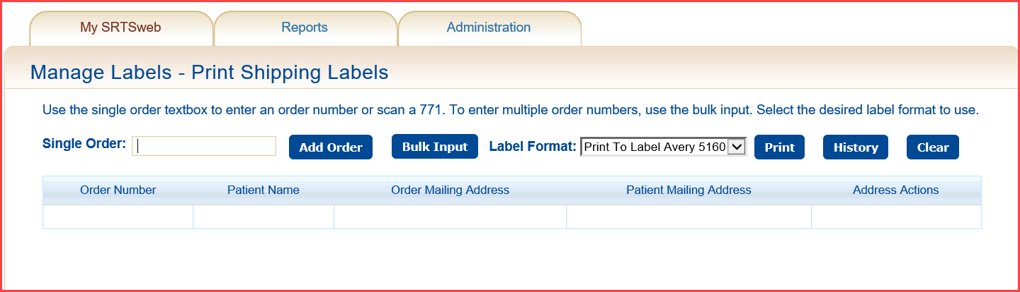

The user has the ability to reprint shipping labels that were designated as Lab Mail To Patient on the order and received. Select History and history item. Press Print.

**NOTE: History labels cannot be update. User must type in order number and press Add Order.**

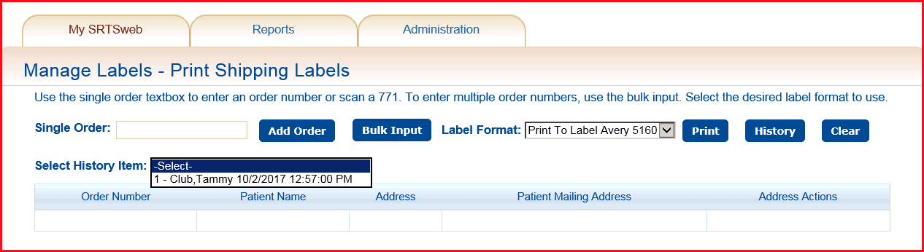

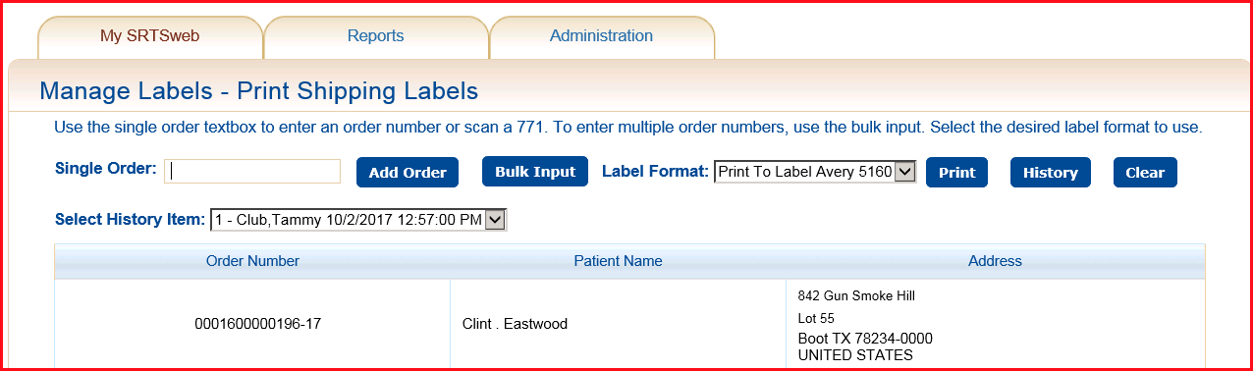

The user has the ability to add orders that were not marked as Lab Mail to Patient by typing, scanning in a single order number and pressing Add Order or Bulk Input and Add.

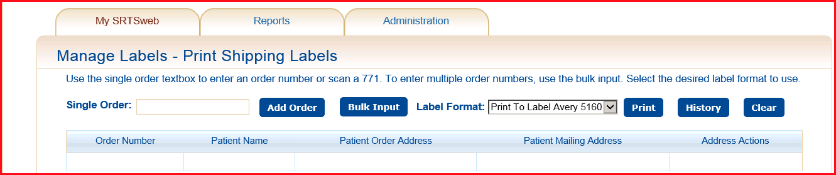

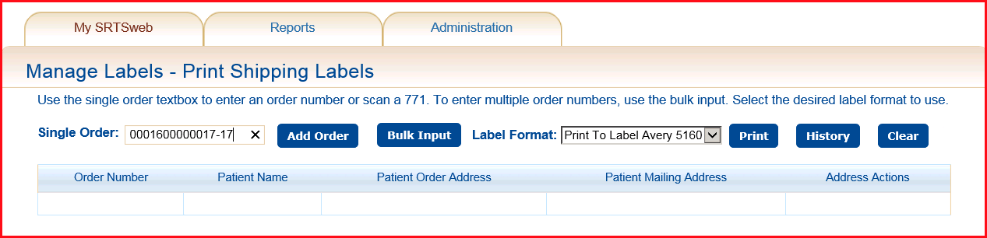

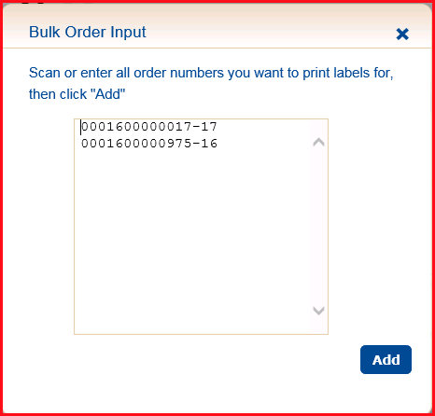

The user has the ability to select patient order address or mailing address. The ability to Update or Delete record.

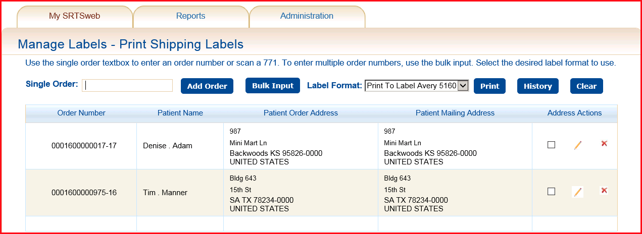

Select to use Patient’s mailing address instead of order address.

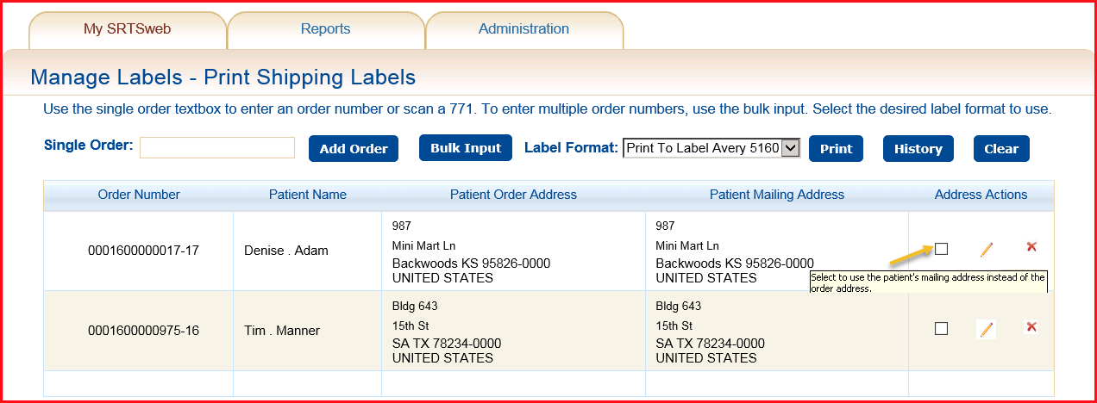

Edit patient’s mailing address.

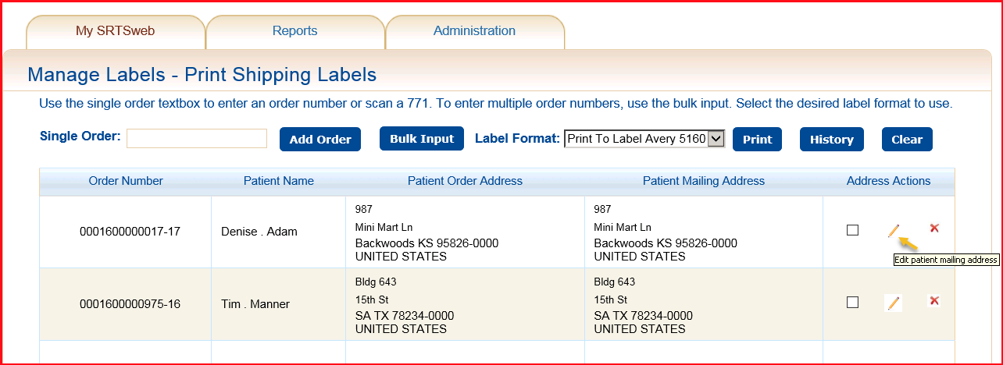

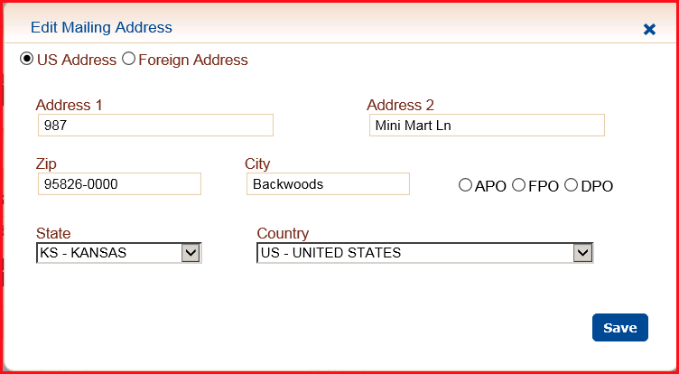

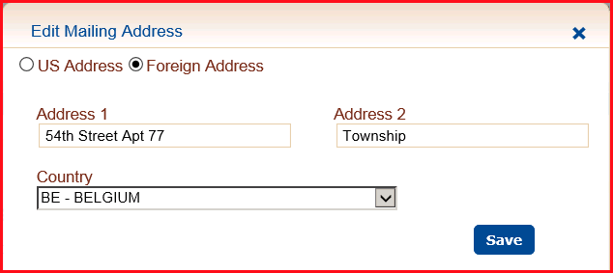

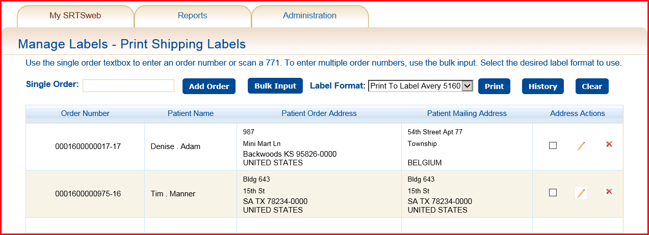

Remove Order Address from grid.

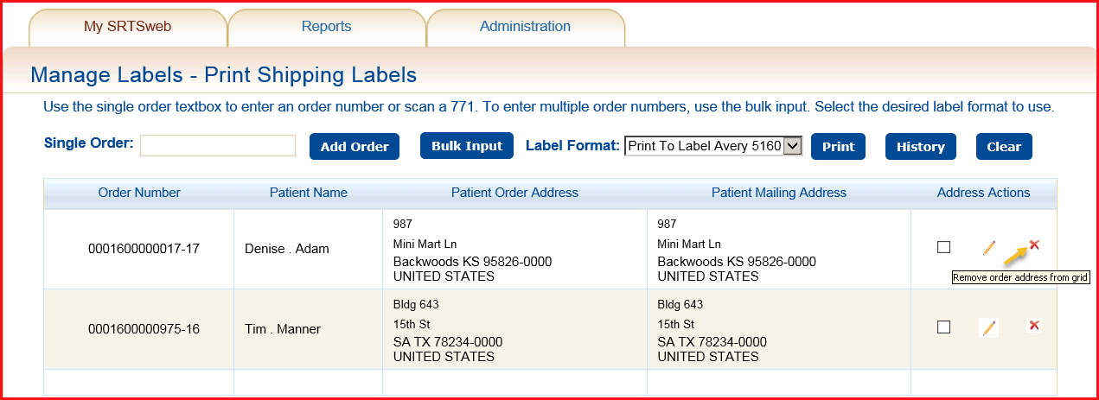

Report samples can be viewed at the end of the SRTSweb User Guide.

# Administration

When the mouse pointer is moved over the Administration tab and a drop down list of Lab Administrator processes will appear.

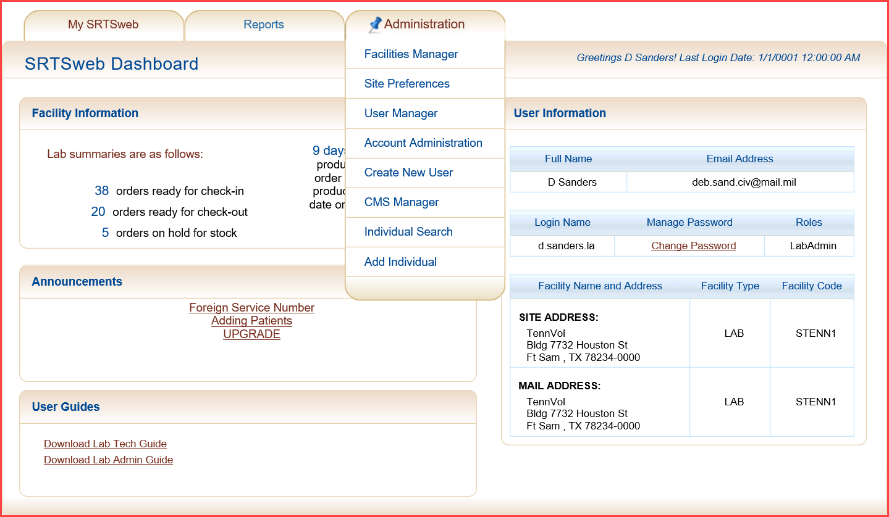

## Facilities Manager

On this screen, the administrator will be able to edit the facility information for the site except for the Site Code.

In the update mode, fields which may not be updated appear grayed out.

To edit the site information, click on the **Edit Site** button at the bottom of the screen. To discard any changes, click on **Cancel** to return to the My SRTSweb Dashboard.

In the Site Address section of the screen, the user can add or update the site and mailing addresses.

Once the updates are completed, click **Update** to save the changes, or click on **Cancel** to discard the changes. If the user does not click the **Update** button before proceeding to another screen**,** the data entered by the user will not be saved.

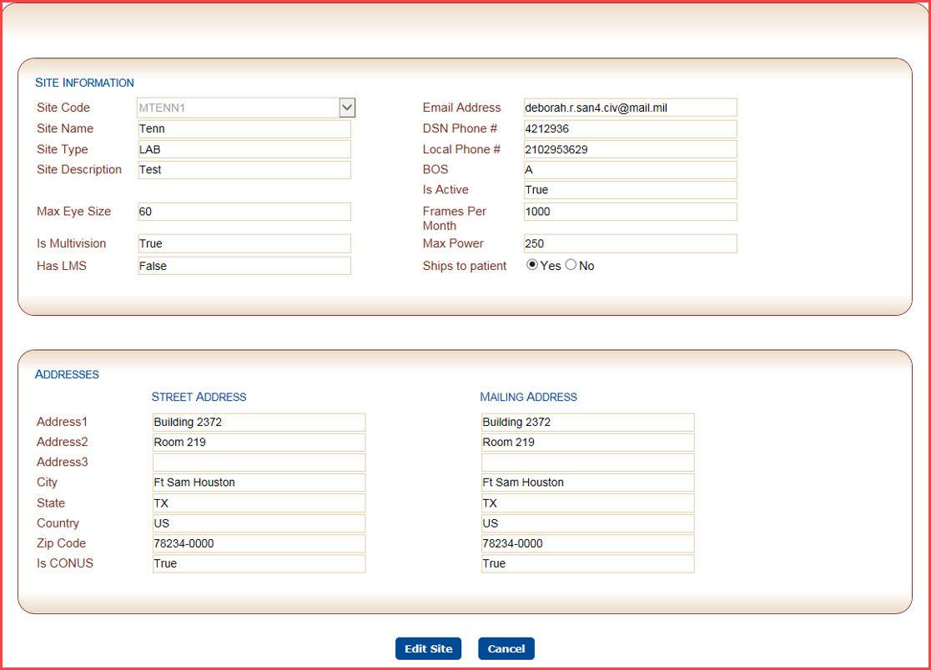

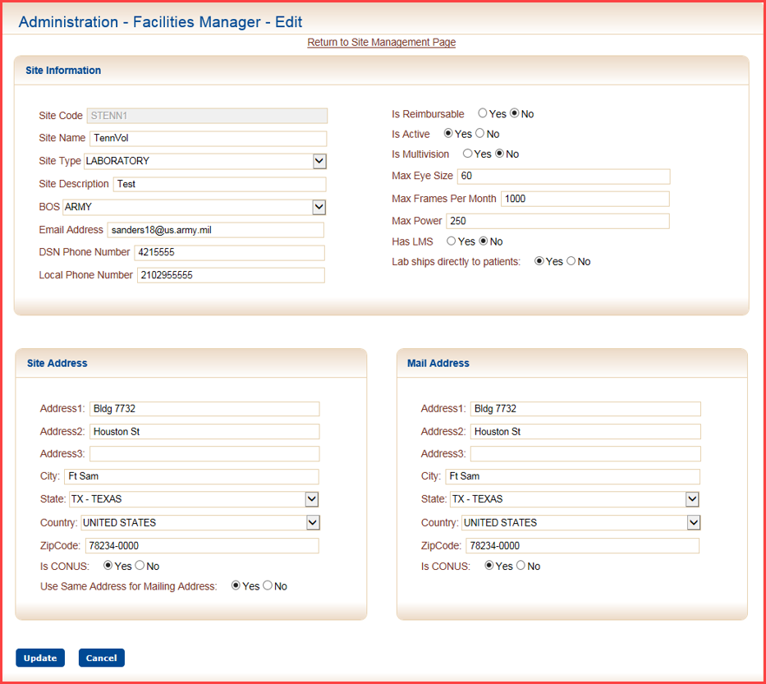

**Site Preferences**

**Lab Parameters**

Lab Admin have the option to setup parameters to allow for proper routing of orders to the correct lab. The lab admin can enter fabrication parameters in quarter diopter measurements. When a clinic tries to add an order, the system determines if the Rx meets the fabrication parameters set up by their respective labs. If the labs assigned to the clinic cannot make the eyewear then the order is automatically routed to a Regional Lab.

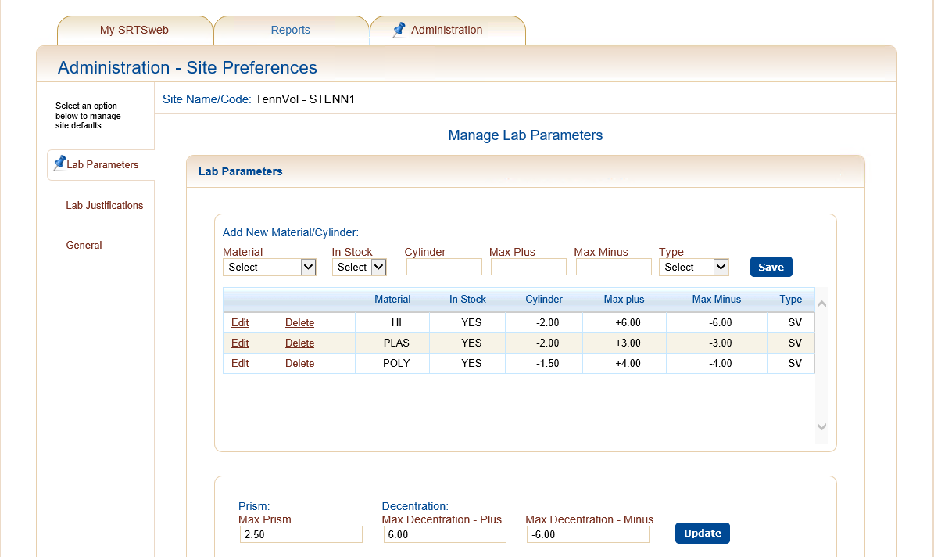

The lab admin chooses a material that the parameters apply to.

Material:

* HI High Index
* LSR Laser
* NVG Night Vision Goggles
* PLAS Plastic
* POLY Polycarbonate
* TRAN Transition

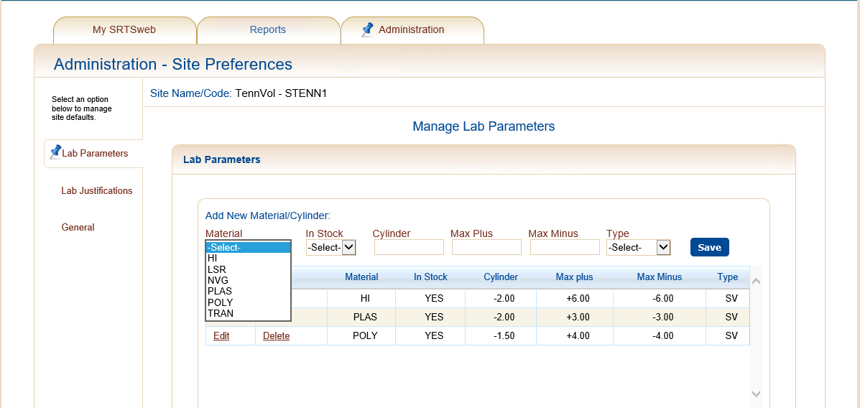

Set the in-stock status of the material.

In Stock:

* YES
* NO

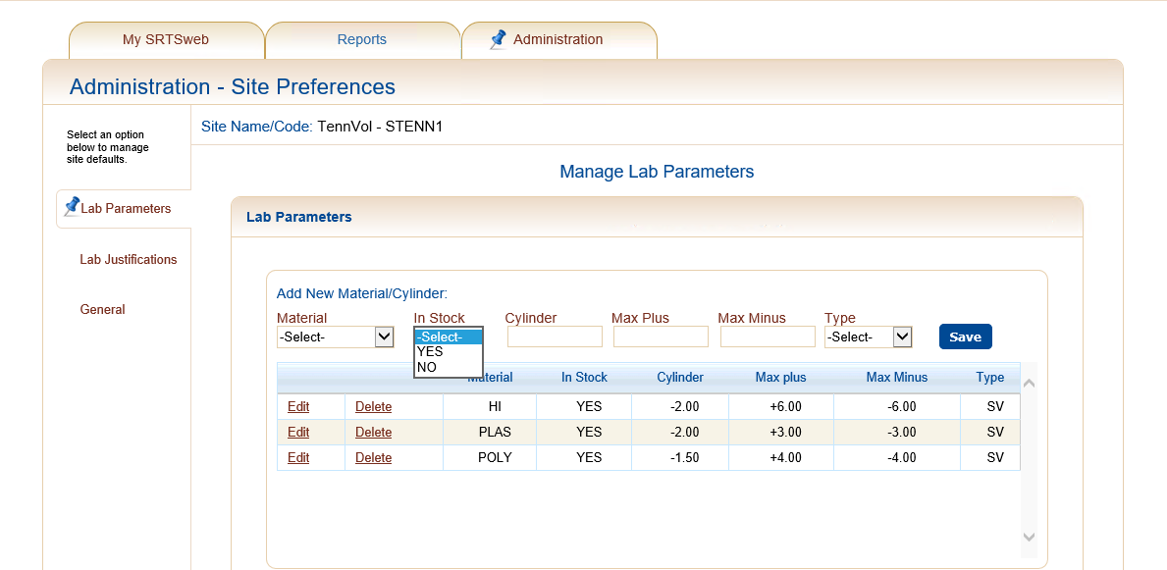

Set a Cylinder value. This is the trigger to determine if a patients Rx should be compared to the fabrication parameters. Cylinder values must be between -5.0 and +5.0, in increments of 0.25. The plus sign has to be typed in.

Set a Max Plus and Max Minus. This is an inclusive sphere range that the lab can fabricate based on the above cylinder.

Select the type of fabrication Lab.

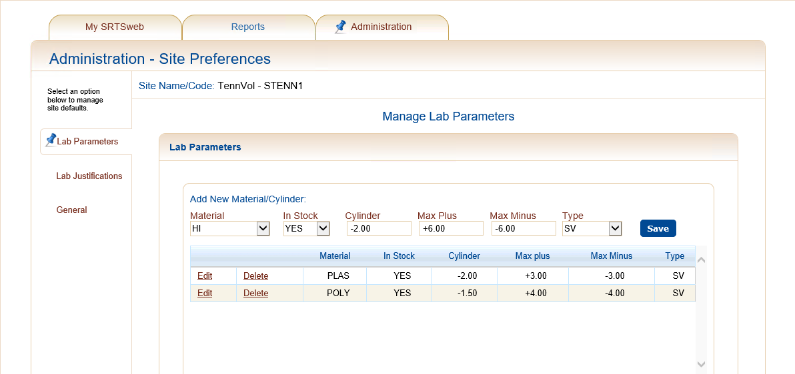

Press **Save.**

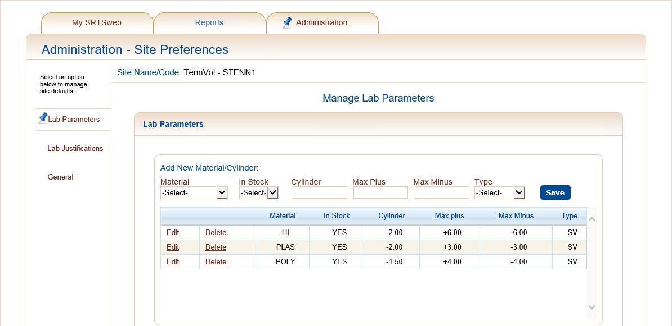

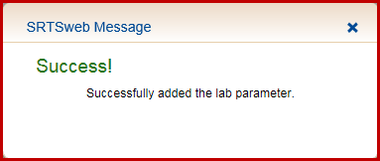

According to this parameter a Cylinder of -2.00 and a Max Plus of +6.00 can be made. If the RX says Cylinder -2.00 and +6.25 the glasses will be sent to the Regional Lab.

You can also define fabrication capabilities based on maximum prism and maximum de-centration. If you cannot fabricate a particular order that exceeds your established parameters, the order will be sent to the Regional Lab. Press Update after values are entered.

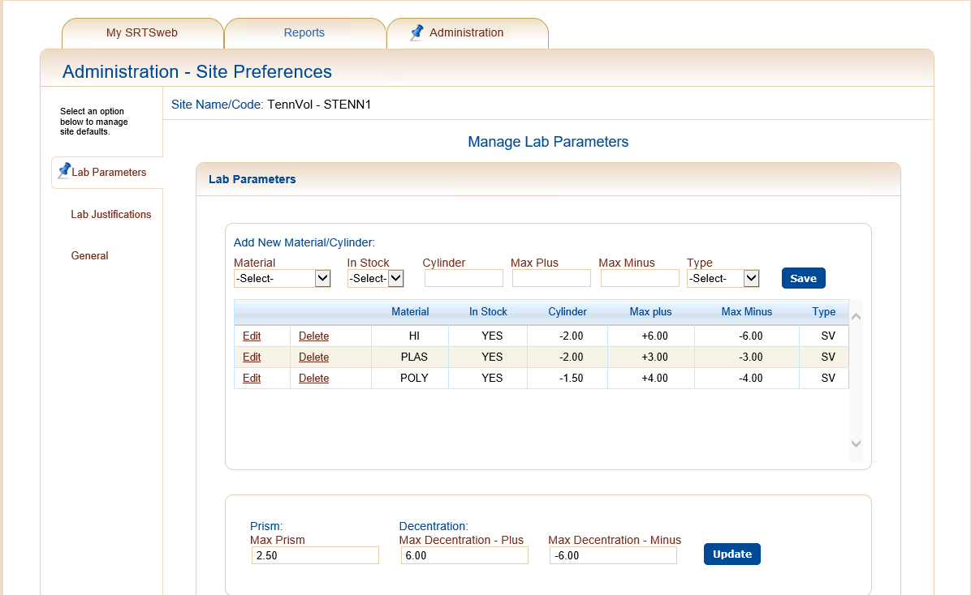

**Lab Justifications**

Lab Admin have the option to setup default reasons for Rejections or Redirect and Delete.

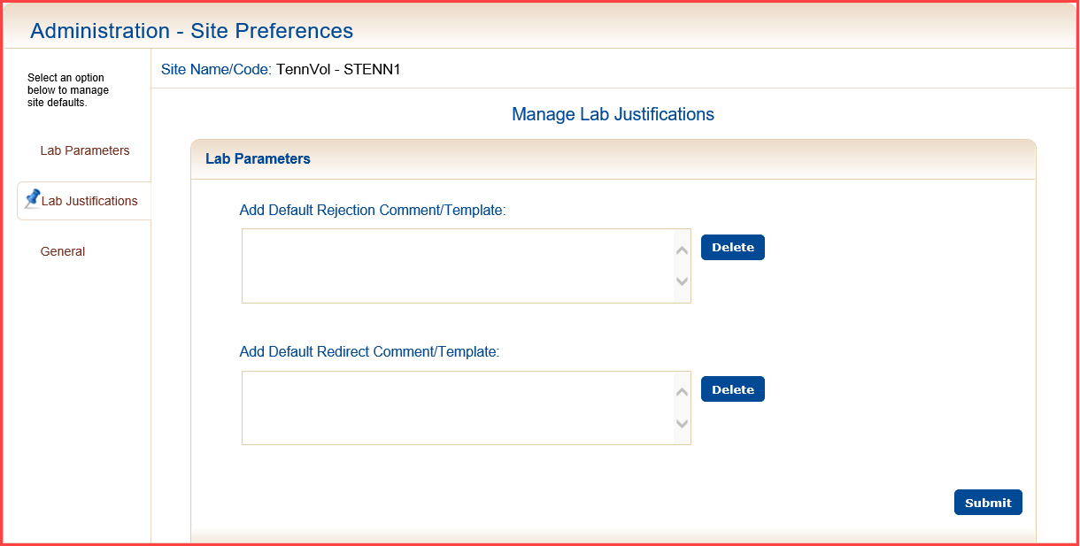

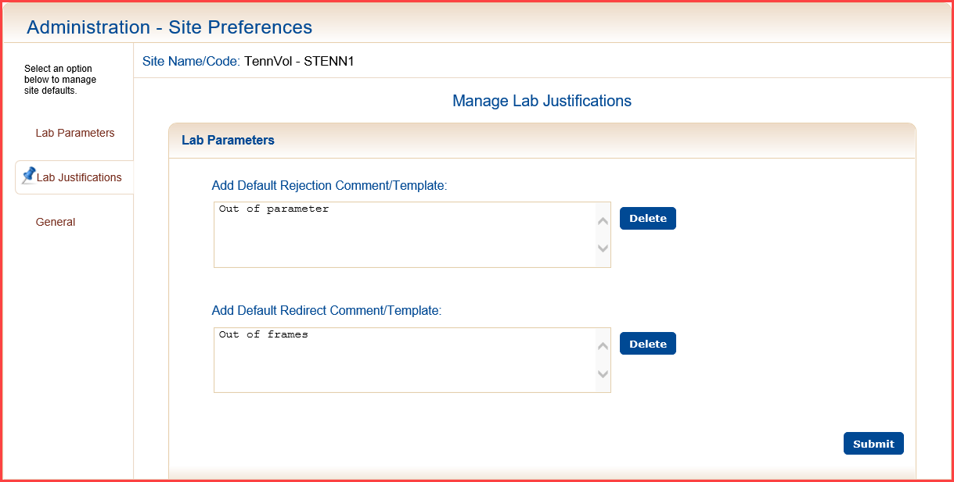

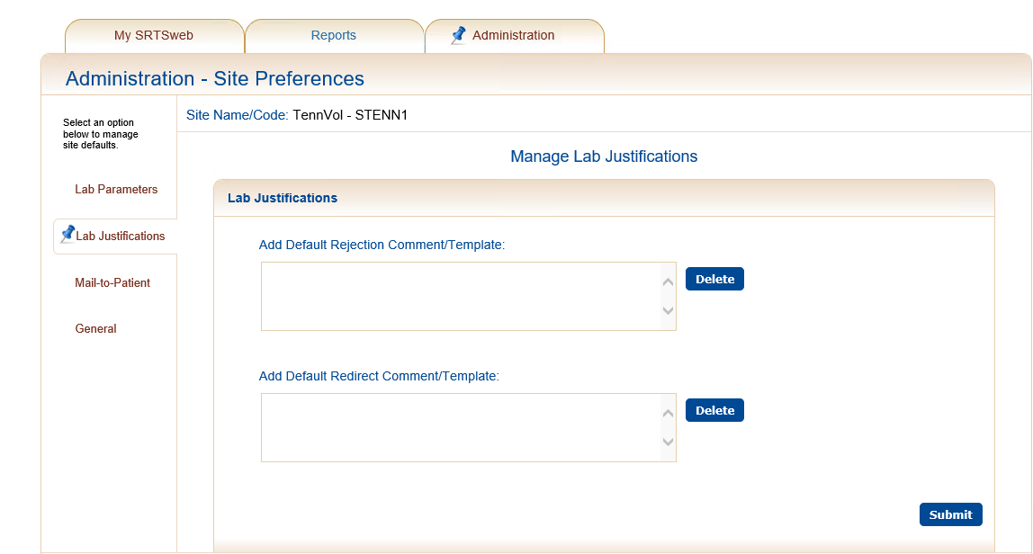

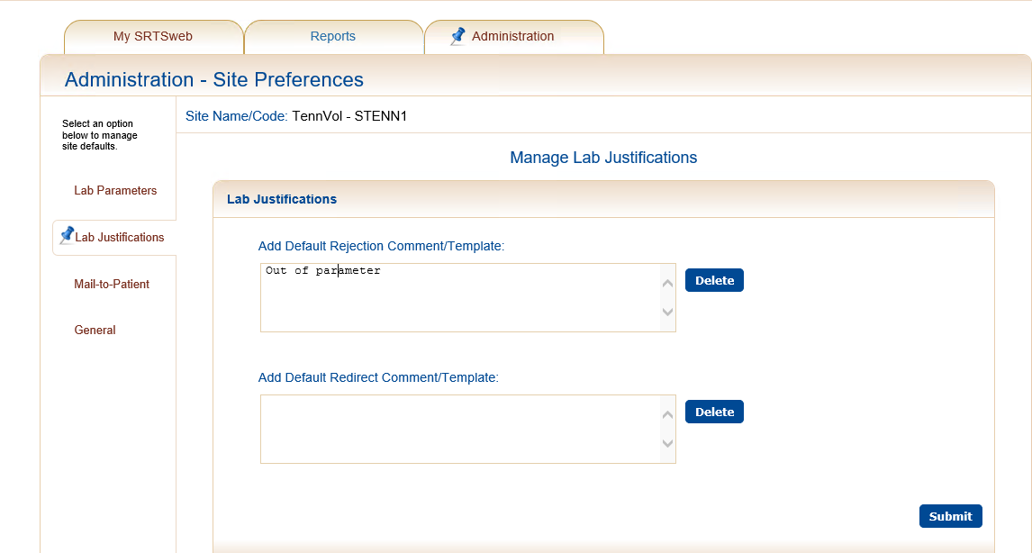

Press **Save.**

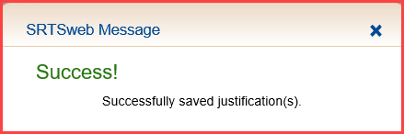

**General**

The lab admin has the option to have mailing labels printed alphabetically by clicking Sort Labels and pressing **Submit**.

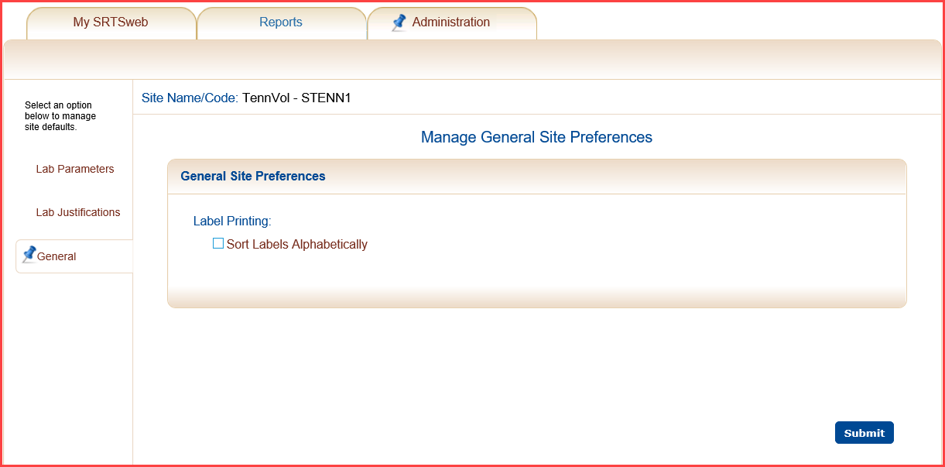

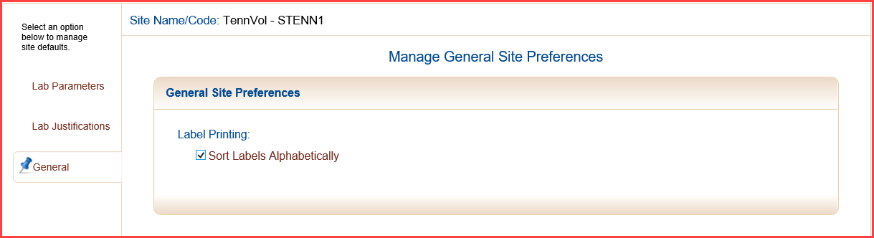

Press **Save.**

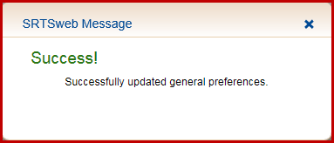

## User Manager

From the Administration screen click on the User Manager option. This screen has five sections under User Profile Information: User Data, User’s Primary Site, User Location(s), Roles Assignment(s) and authorization to manage CMS.

The user has the option to search a user by username or partial user name to update the user’s profile.

The logged on user can NOT make changes to their account while they are logged on.

An email notification will be sent to the admin when a user’s account has been notified.

Modifications to user deb.lt:

Site, STENN1, approved: True.

Changed users email address.

Made by Sanders,D - 2019732 on 5/30/2017 7:30:47 AM.

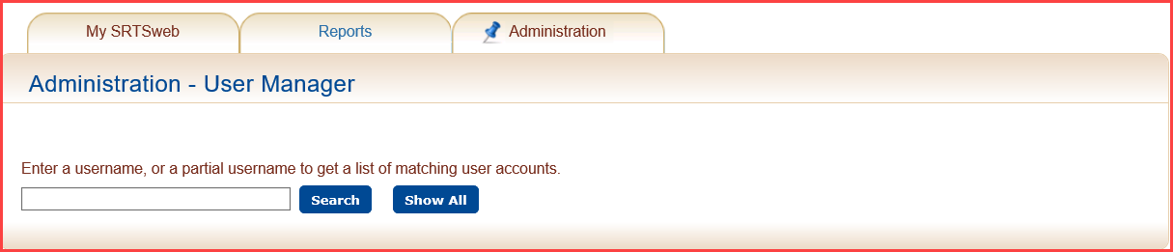

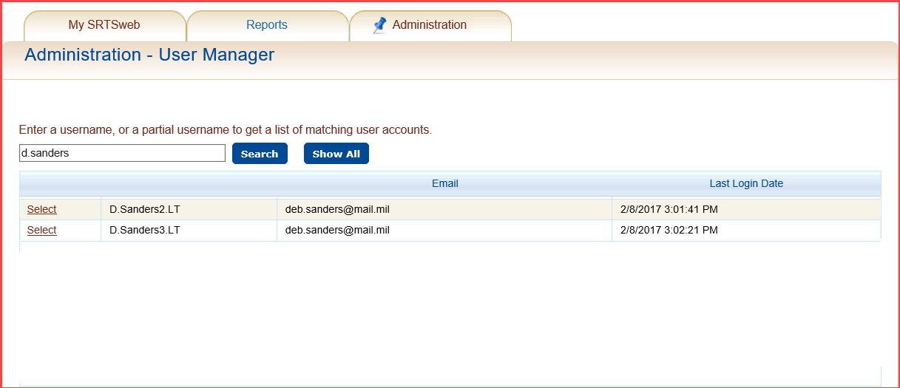

**User Profile Information**

The user has to be approved to the site by the administrator. When the user is built the system automatically approves the user. If the user is assigned to a different location the admin at the new location has to approve user before the user can sign in.

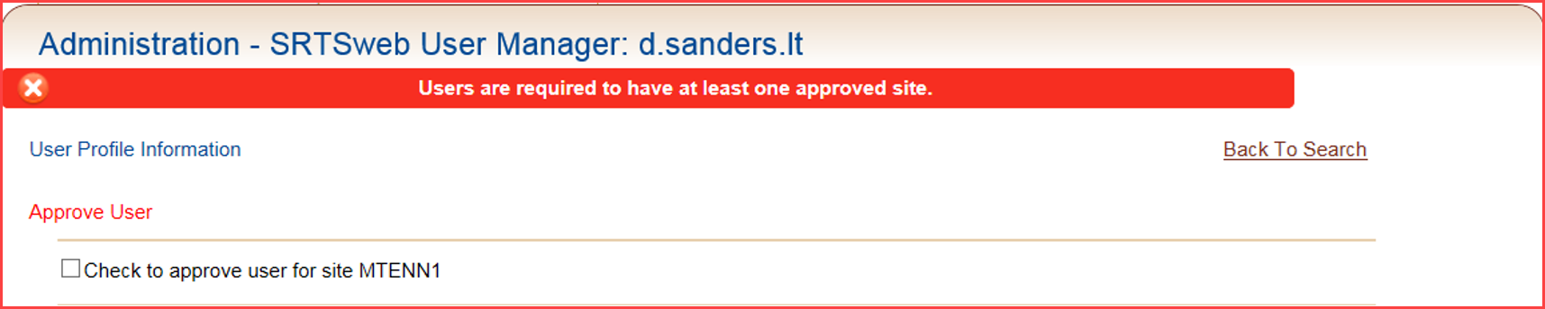

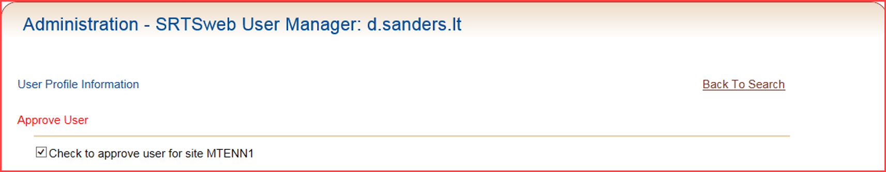

**User Data**

Under User Data the user can update the user’s name and email address. Press the Submit button.

The Is User CAC Enabled will show whether or not the CAC has been registered. A True or False will show. True meaning the CAC has been registered.

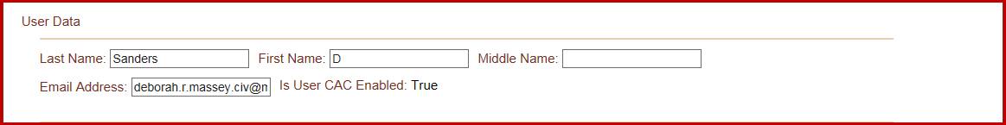

**User’s Primary Site**

Under User’s Primary Site the user can be moved to another site and approved by the new site administer. Primary Site tells the user which site is their home site if they are attached to more than one site. Press the drop down arrow, select site and press Submit.

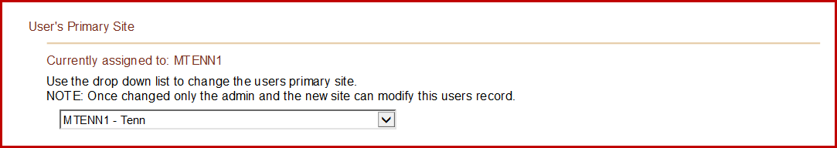

**User Location (s)**

The admin user can assign another site to an existing user at their logged in location. Highlight the other site and click the green arrow to the right. Press the Submit button.

This gives the user the ability to work at multiple sites with one login.

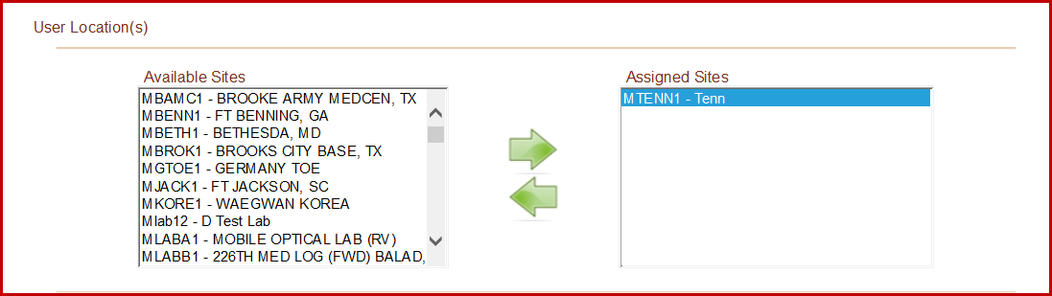

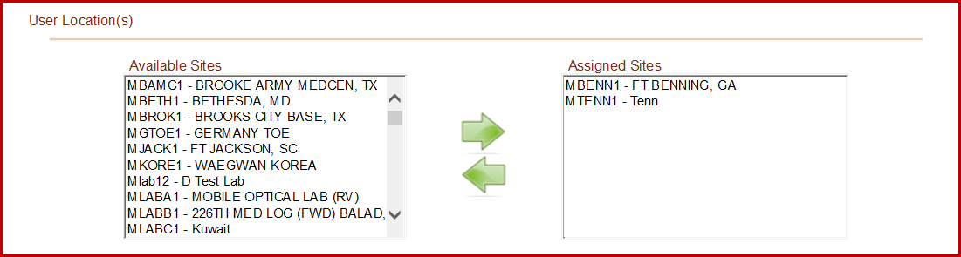

**NOTE:** The assigned site admin had to **Approve User** before the user can log in.

**Role Assignment(s)**

Users must have a role assigned. Roles are made when adding an Individual. The user can update the role here. To assign a role to the user, click on the role in the **Available Roles** list and the click on the green right pointing arrow. To unassign a role for the user, click on the role in the **Assigned Roles** list and click on the green left pointing arrow. Press the Submit button.

The Lab Admin role cannot be assigned with a lab user role (Lab Clerk and Lab Tech).

When assigning roles keep in mind the functions that the user will have. A clerk does not have all the capabilities that the tech has. Do not add both clerk and tech to the same user.

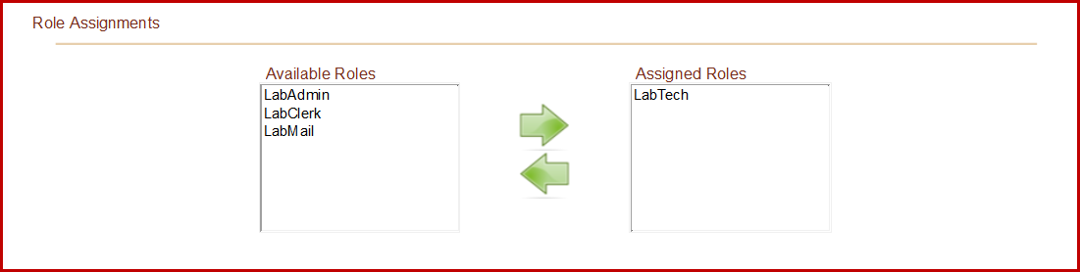

**CMS**

When the user is created the admin has the option to check CMS. This option gives the admin the capability to update the user to allow CMS by checking box. Press the Submit button. This option will not be seen unless CMS is checked when creating the user.

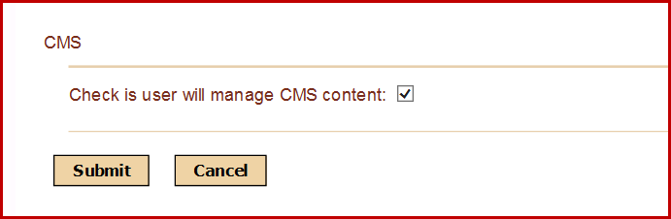

Pressing submit after each option is not necessary just as long as the user presses Submit before exiting the screen.

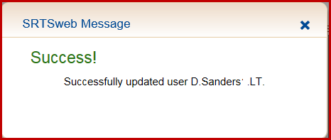

**Account Administration**

**Enabling and Disabling a User Account**

From the Administration tab drop down menu, select the User Administration option to display the screen to manage user accounts. This screen has three sections including: Disable Users Account, Enable Users Account, and Undo Password Lockout for Users Accounts.

To Disable a User Account, highlight the name of an enabled user account and press **Disable User**.

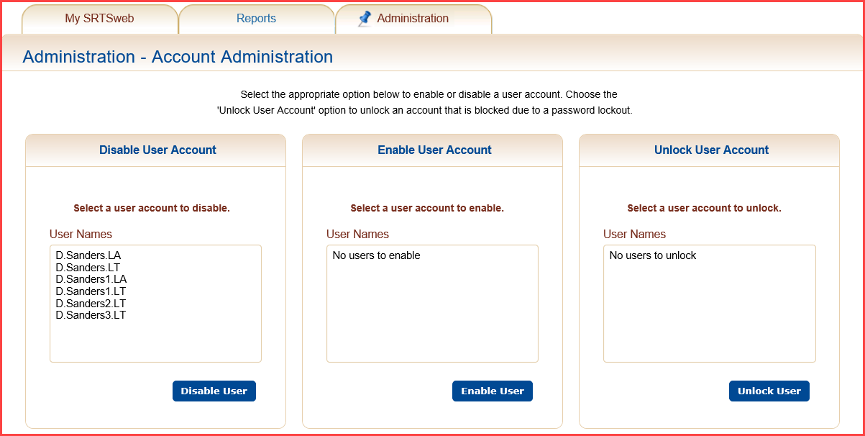

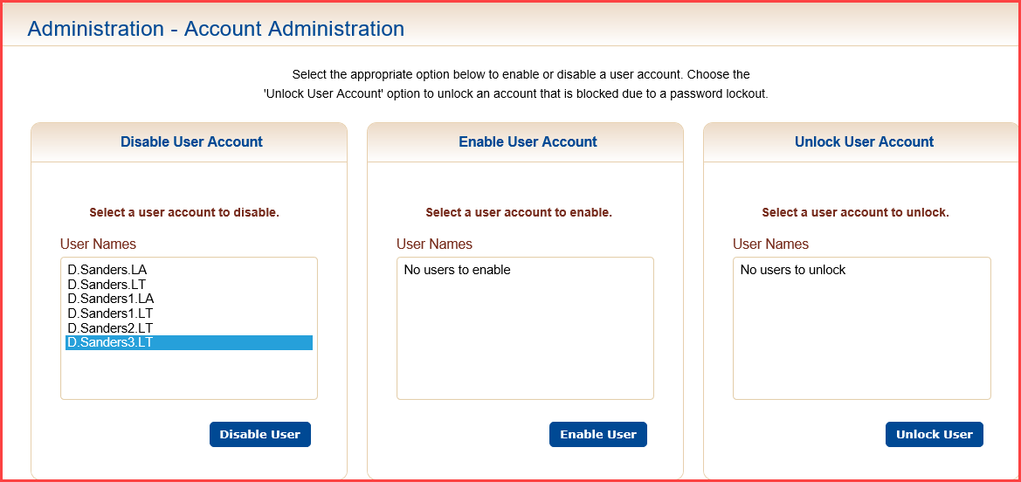

A message box will pop up to confirm disabling the specified user.

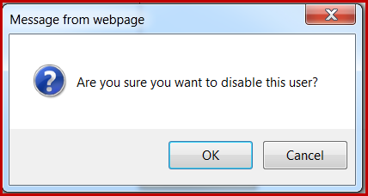

Press **OK** to save the changes. A confirmation message will be displayed.

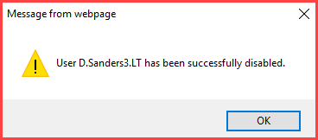

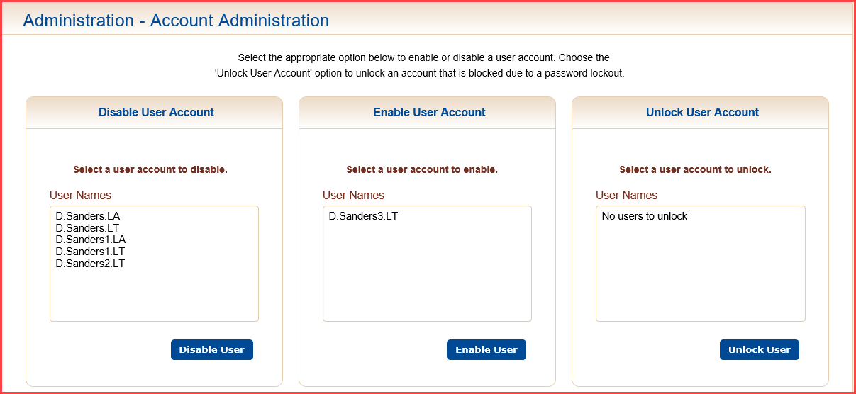

An email notification will be sent to the admin when a user’s account has been disabled.

User D.Sanders3.LT was disabled by d.sanders.la on 12/8/2017 12:26:30 PM.

To Enable a User account, highlight the name of a disabled user account and press **Enable User**.

A message box will pop up to confirm enabling the specified user.

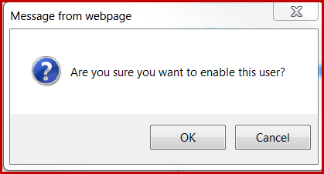

A confirmation message will appear that the user has been successfully enabled.

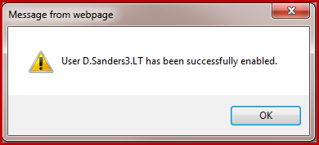

An email notification will be sent to the admin when a user’s account has been disabled.

User d.sanders3.lt was enabled by d.sanders.la on 5/12/2017 1:27:08 PM.

#### Unlocking a User Account

After 3 unsuccessful login attempts, a user account will have the user’s password locked. To unlock a user whose password has been locked, highlight the user name in the Undo Password Lockout for User Accounts list and click on the **Unlock User** button.

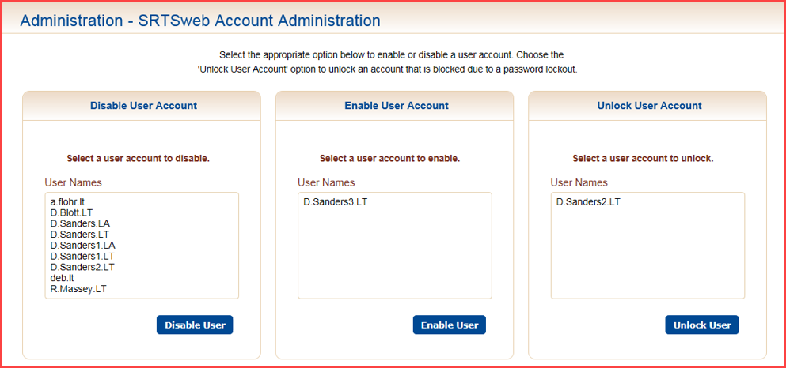

A confirmation message box will be displayed to confirm unlocking the user account.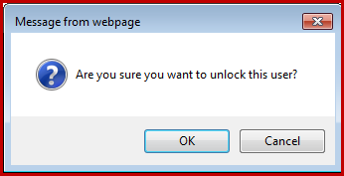

Click the **OK** to unlock the user account. A confirmation message will appear.

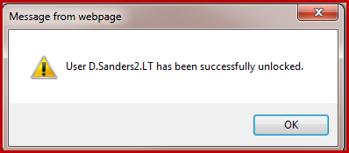

Click **OK** to return to the Account Administration screen.



An email notification will be sent to the admin when a user’s account has been unlocked.

User d.sanders2.lt was unlocked by d.sanders.la on 5/12/2017 1:27:08 PM.

### Create New User

From the Administration screen click on the Create New User option.

#### New User Creation Wizard

The SRTSweb administrator may create a new user by going to Administration – Create New User.

The steps required to create a new user account are:

* Enter DOD ID or SSN
* Press **Search** or **Enter**
* Add user’s email
* Check CMS access if applicable
* CAC enable this User will default if applicable
* Assign user role
* Press Submit

**NOTE:**  **CAC Enable This User will not show up if DOD is not added on Individual.**

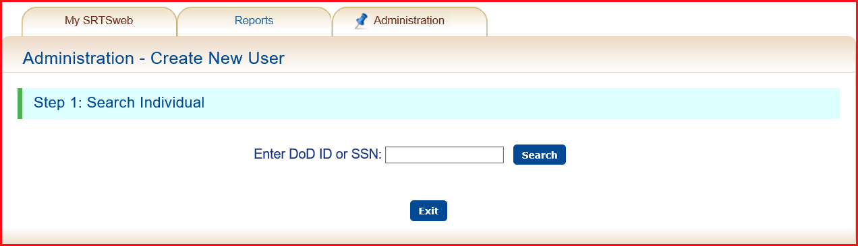

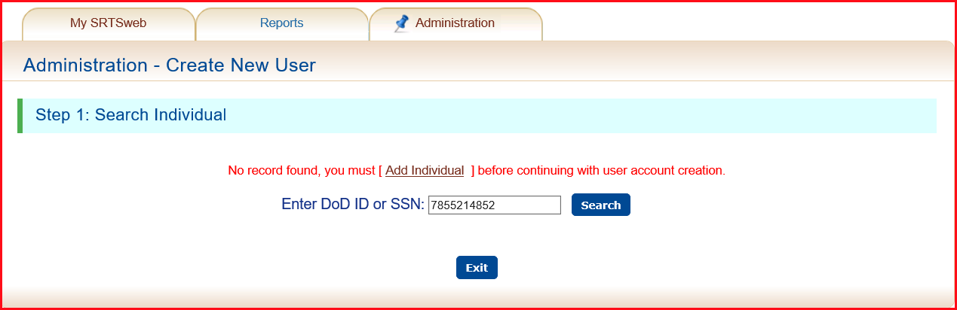

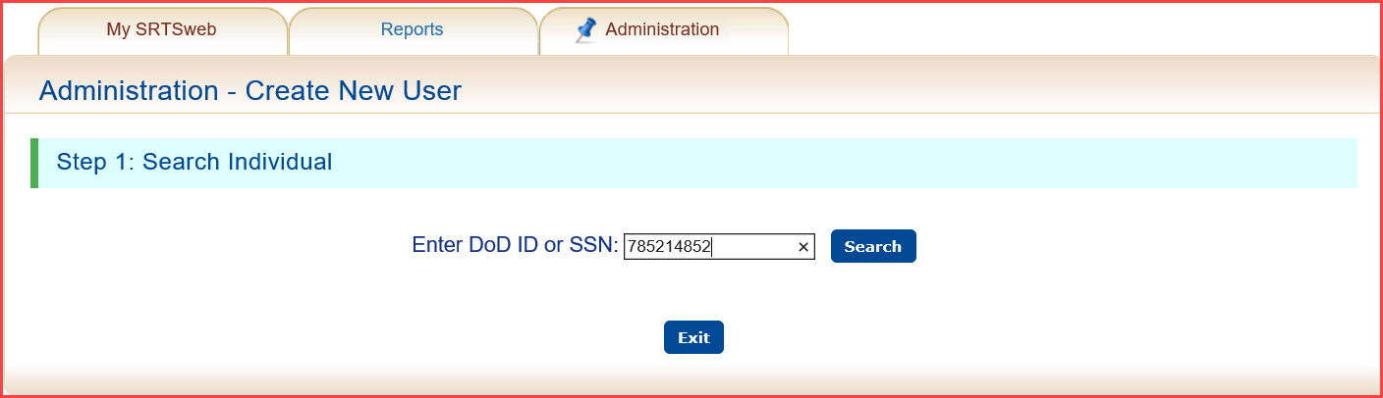

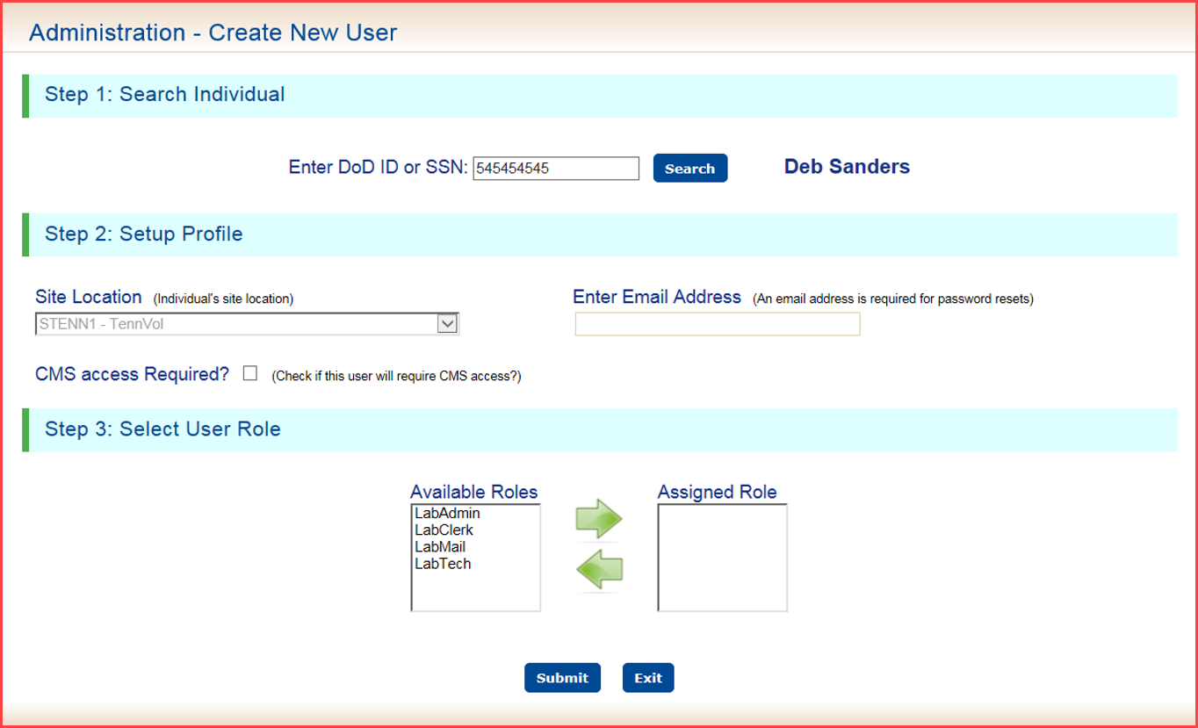

**Setup Profile**

The user site location is defaulted and grayed out. This will be your location.

**Enter Email Address** of the user being created.

Check **CMS** access if applicable.

The **CAC Enable this User** will be checked by default.

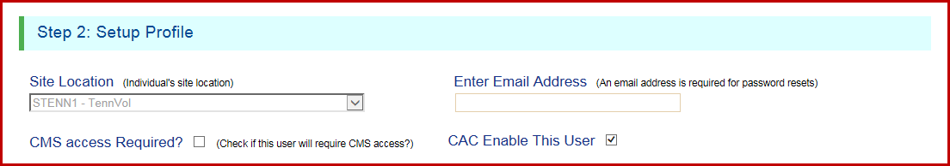

**NOTE:**  **CAC Enable This User will not show up if DOD is not added on Individual.**

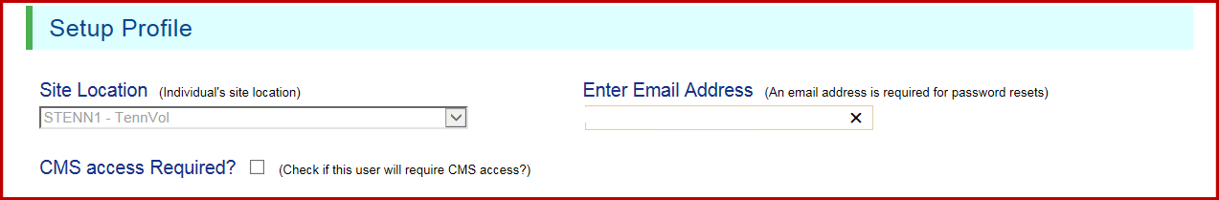



**User Roles**

A list of available roles that can be assigned for the selected user is displayed in the **Available Roles** list.

To assign a role to the user, click on the role in the **Available Roles** list and the click on the green right pointing arrow. To unassign a role for the user, click on the role in the **Assigned Roles** list and click on the green left pointing arrow.

The Lab Admin role cannot be assigned with a lab user role (Lab Clerk or Lab Tech).

The user must be assigned at least one role before having access to the SRTSweb application.

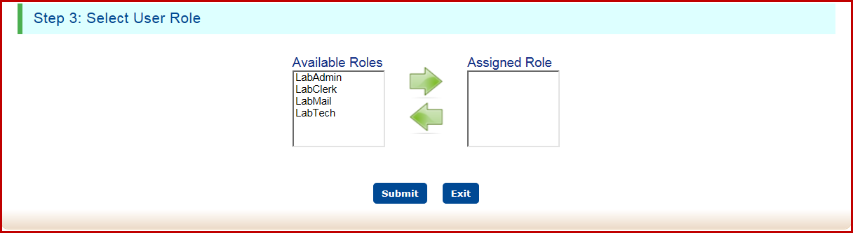

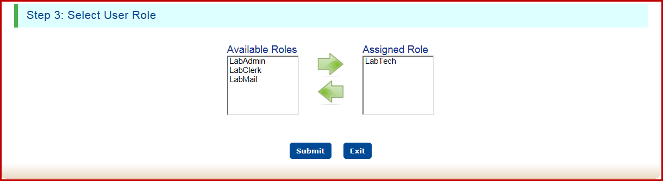

**Press Submit** to save the record or **Exit**.

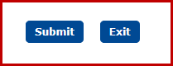

Depending on the user’s individual record the user creation wizard will email a password to the user if the DOD is not added in the individual record. After logging in with password, the user has the option to register his CAC.

If user has a DOD added in the individual file the admin can enable this user to log in with his CAC. No password will be emailed to the user.

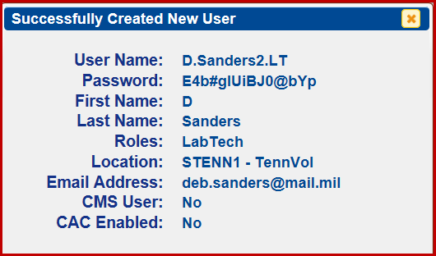

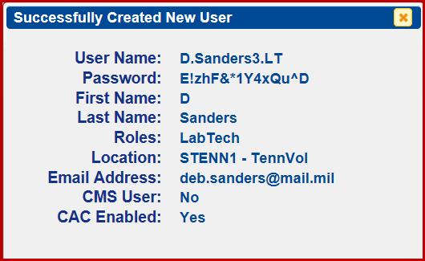

The **CAC Enable this User** will not show if the user does not have a DOD record on file.

The user will be routed back to the Create New User Screen.

Once all the steps to create a new user have been accomplished, the new user is ready to login and begin using the SRTSweb application.

If the User that is being created does not exist as an Individual first the message and link below will appear.



Pressing the **Add Individual** link will take the user to the Manage Individuals – Add Individual page. Add the individual ID type and ID Number press enter.

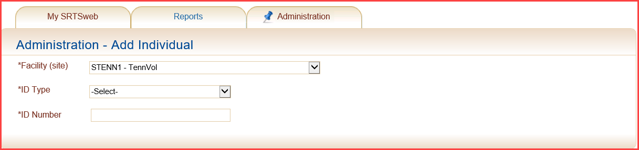

Click the appropriate Individual Type Information before going back to **Create New User**.

More information is found under the Add Individual or Search Individual section.

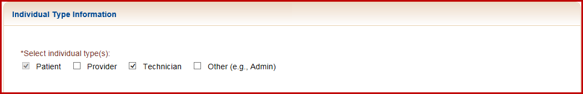

An email notification will be sent to the admin when a new user’s account has been established.

User d.sanders3 was added by d.sanders.la on 5/12/2017 1:27:08 PM.

## CMS Manager

The CMS (Content Management System) Manager module under the Administration tab allows users with administrator level privileges to enter, post, and manage messages and announcements with two different audience scopes, Lab or Global.

The user may access the Content Management System (CMS) by clicking on CMS Manager in the Administration tab drop down menu.



The user must have their Individual name that is on file in the SRTSweb database, synced on CMS on the profile page under User Manager to use the CMS Manager.



If the screen displays the following message, the user is not synced to use CMS.

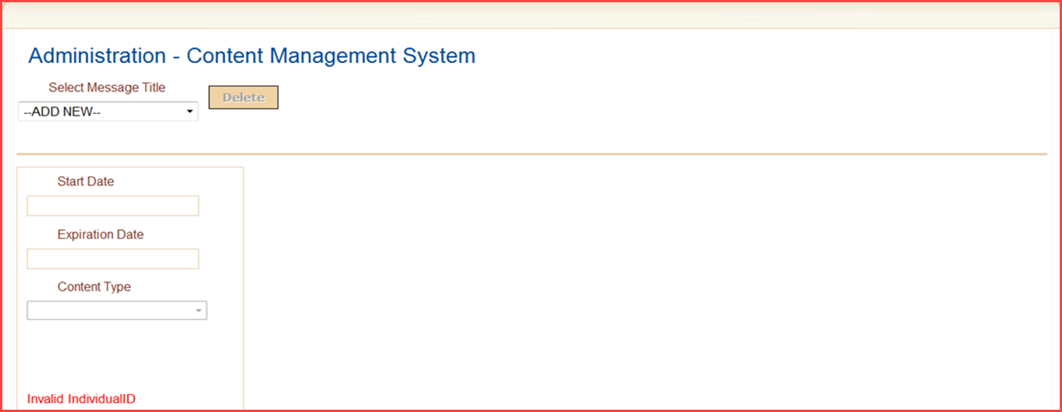

In the Select Message Title field, a drop down list is provided for selecting either adding a new record or selecting a message title for announcements currently stored in the SRTSweb database.

To add a new message or announcement, click on Add New in the Select Message Title Field and enter a start and expiration date.

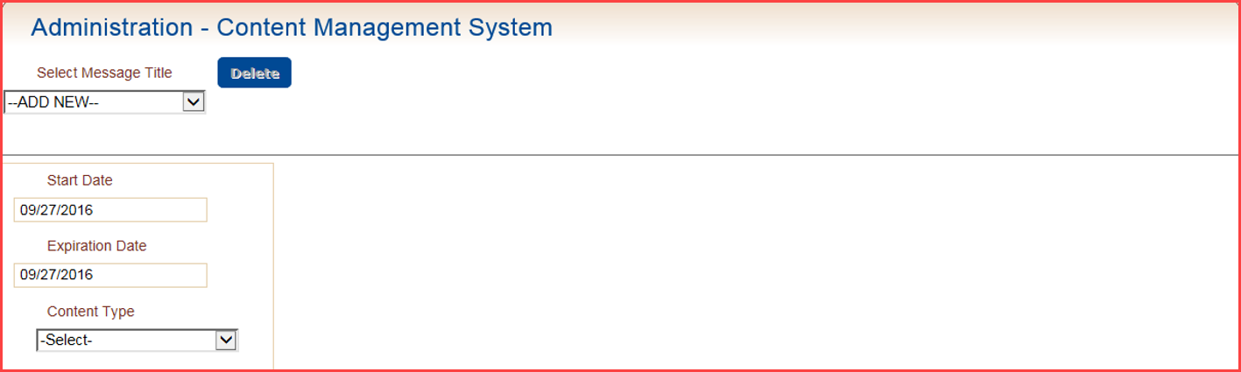

The Content Type field provides a drop down list of message types. A subset of these options will appear in the drop down list:

* Application Announcement – An application announcement is a content type that will be displayed in the section SRTSweb Announcements.
* Message Center – A message is a content type that will be accessible in the section SRTSweb Announcements at the right of the My SRTSweb dashboard or by navigating to My Message Center.

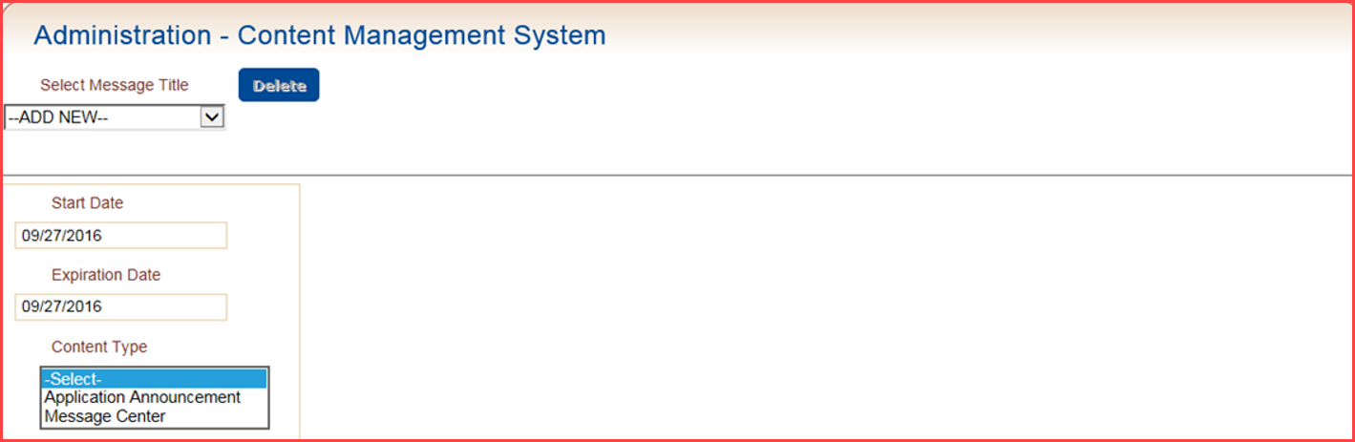

The Recipient Type field will define the recipient scope of the broadcast. The 2 options for this field are:

* Global – will display the announcement in the Message Center for all users globally
* Lab – will display the announcement in the Message Center for users at the local facility only

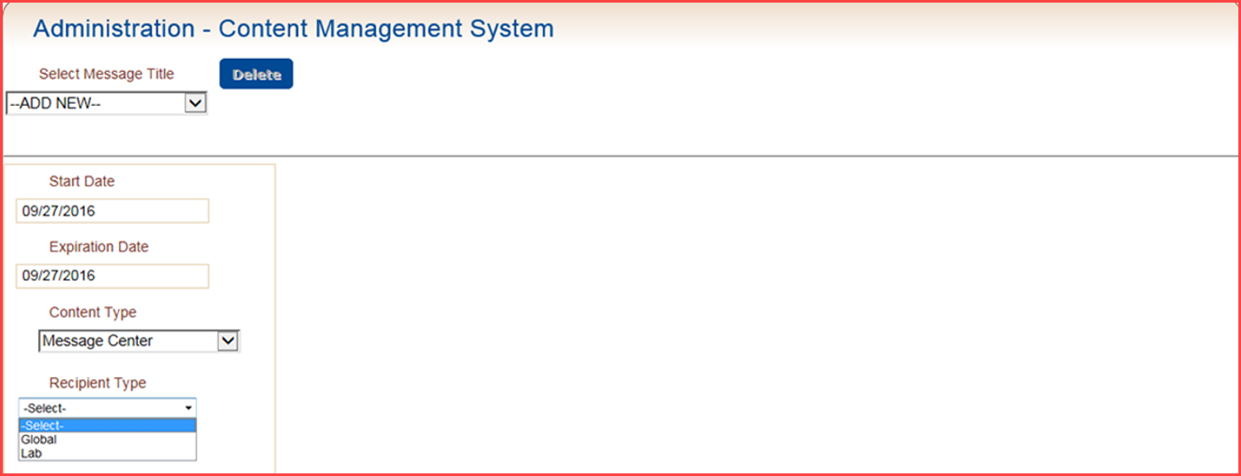

If Lab is selected for the Recipient Type field, a Lab Name field is displayed. A drop down list is provided for the administrator to select the facility to receive the message or announcement. The clinics that the Lab supports will be available for selection.

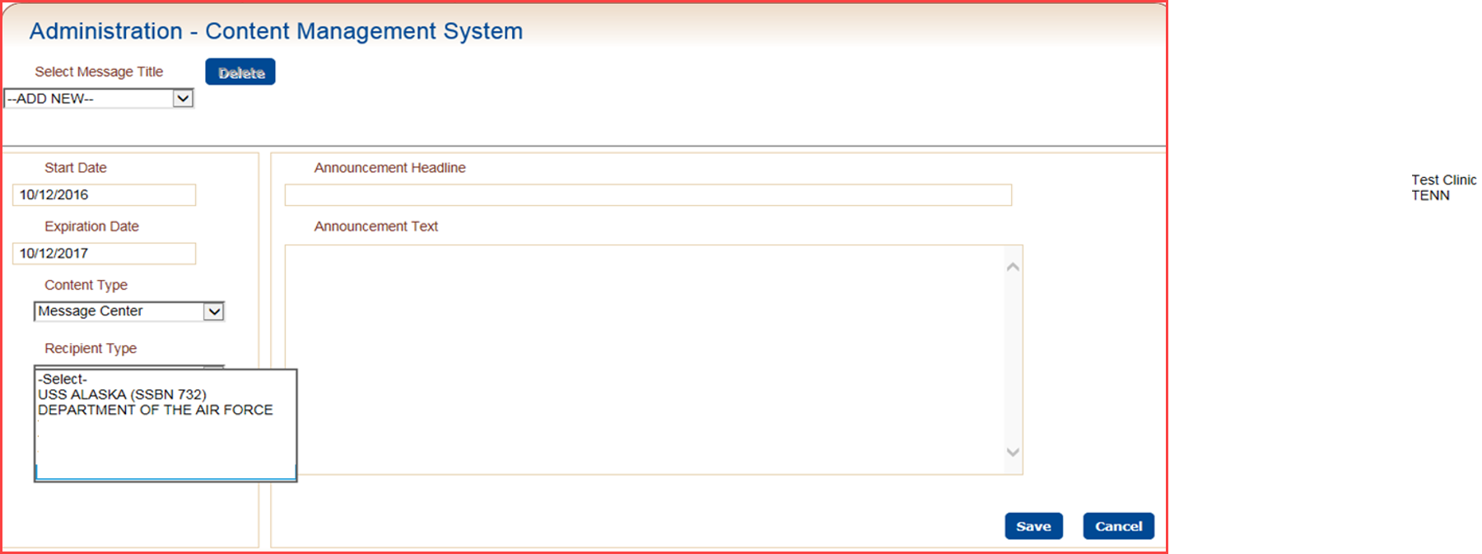

If Global is selected for the Recipient Type field, the Lab Name field will not be displayed.

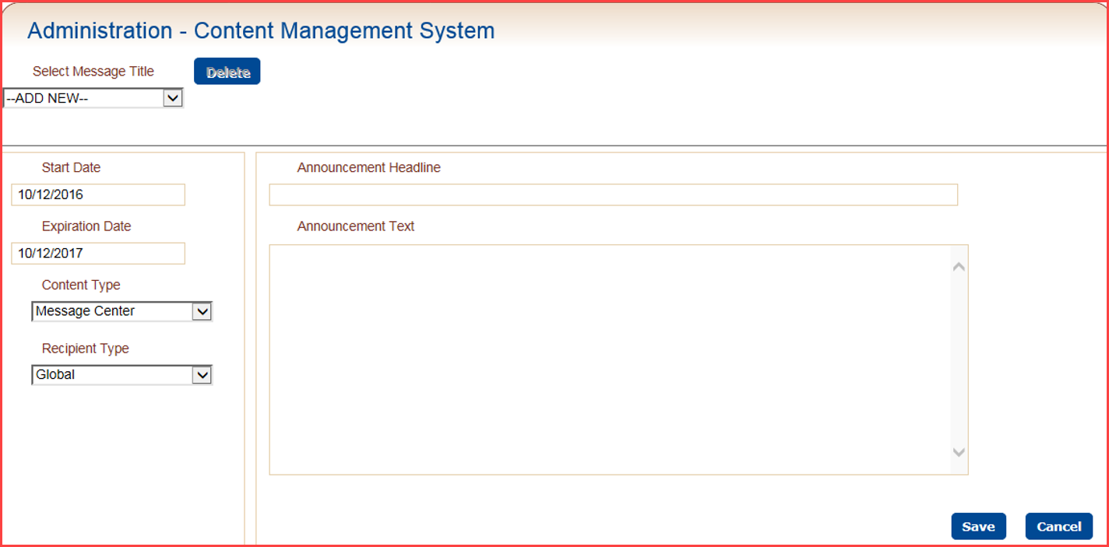

Once the data entry is complete, the screen will display fields for Announcement Headline and Announcement Text.

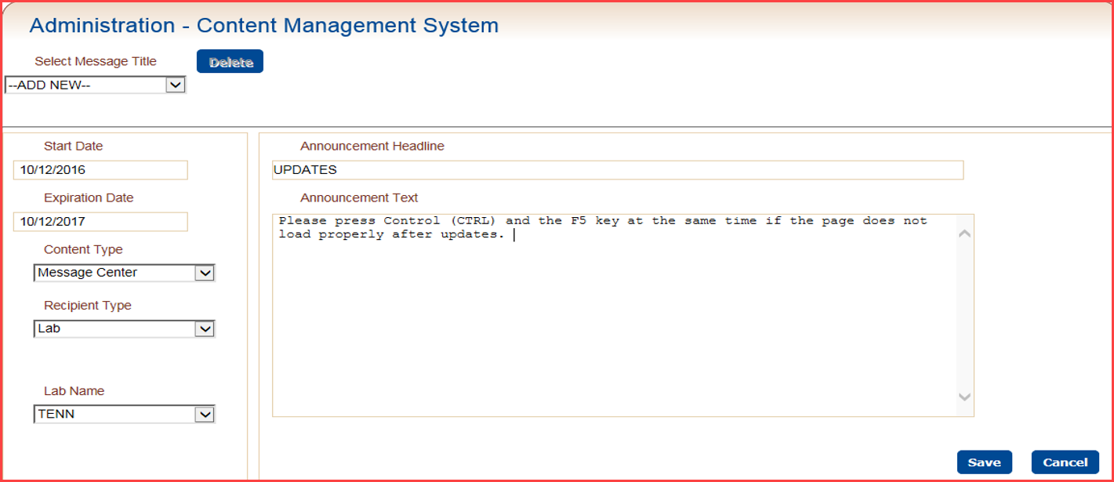

Click **Save** to save the announcement record, or click **Cancel** to reset the screen with blank data fields.

A message will appear to confirm success.

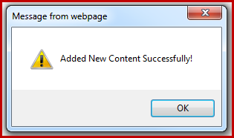

Once the announcement record is saved, users at the selected facility will now see the title and full text of the announcement or message in the **My SRTSweb Message Center** screen. Additionally, the title of the announcement will display on the My SRTSweb Dashboard in the SRTSweb Announcements section. Clicking on the announcement title will take the user to the My Message Center screen showing the full text of the selected announcement. If the Recipient Type selected was Global, all SRTSweb users will see the announcement.

The announcement will show the date message was created; who created the message and how many more days the message will be visible.

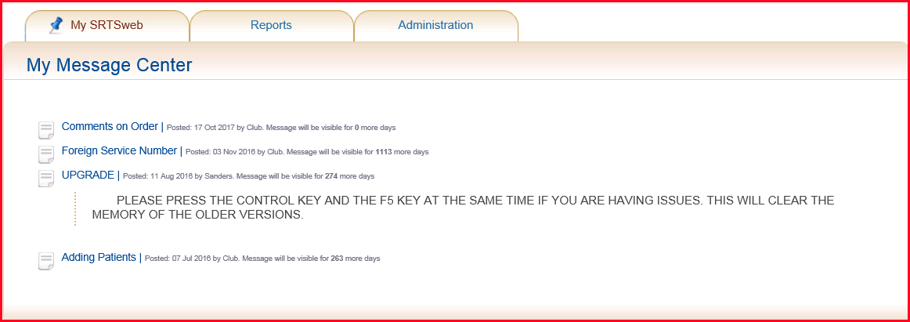

To **Delete** the message select message title by the dropdown. Content Type, Recipient Type and Clinic name has to be selected to pull message up. Press **Delete**.

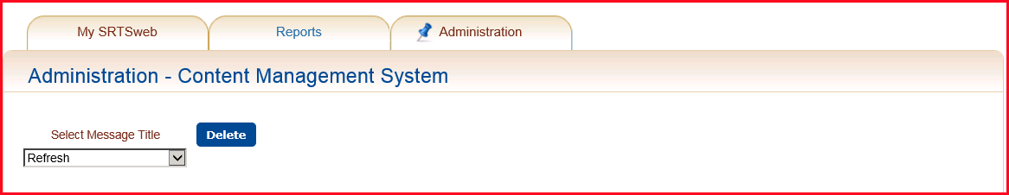

## Individual Search

Individuals are different than users. Users may login to the SRTSweb application and enter data, process orders, or manage parts of the application. An individual is a person who is referenced in the SRTSweb database, and can be a user, but the person is assigned an Individual Type (Technician, Provider or Other – Admin/Clerk).

To search for an individual select the Individual Search option from the Administration tab on the Dashboard.



Searches may be performed based on Last Name, ID/SSN, and/or Individual Type. The search may be limited to **Search Local** for a specified site or expanded to **Search Global**.

Searches may be performed by selecting type of individual.

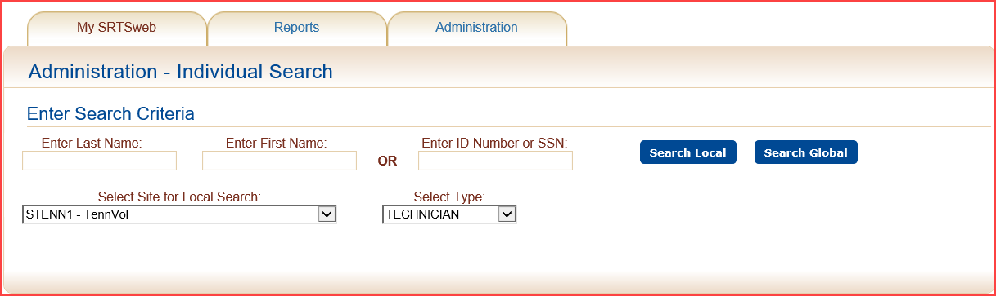

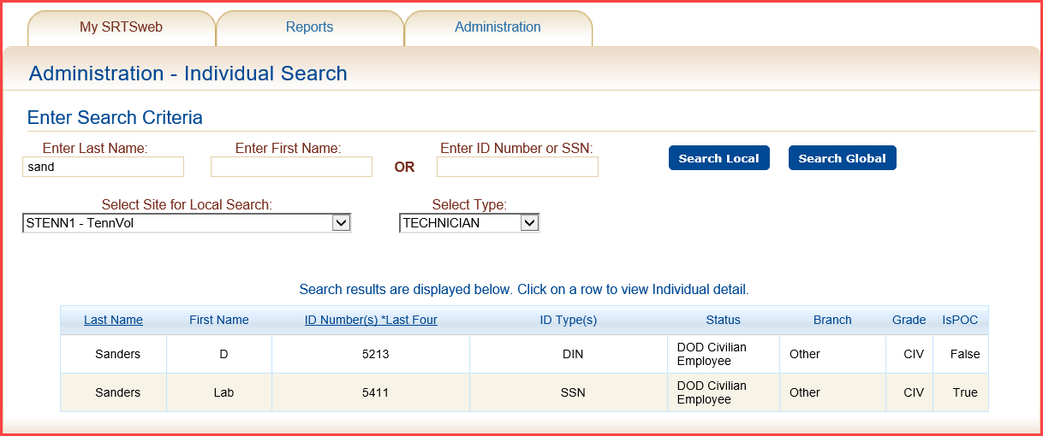

The system will return a set of records matching the search criteria entered by the user. For example, if the search specifies Technician as the Individual Type and the user clicks on the **Search Global** button, the system will display the entire list of Technician that are loaded into SRTSweb database.

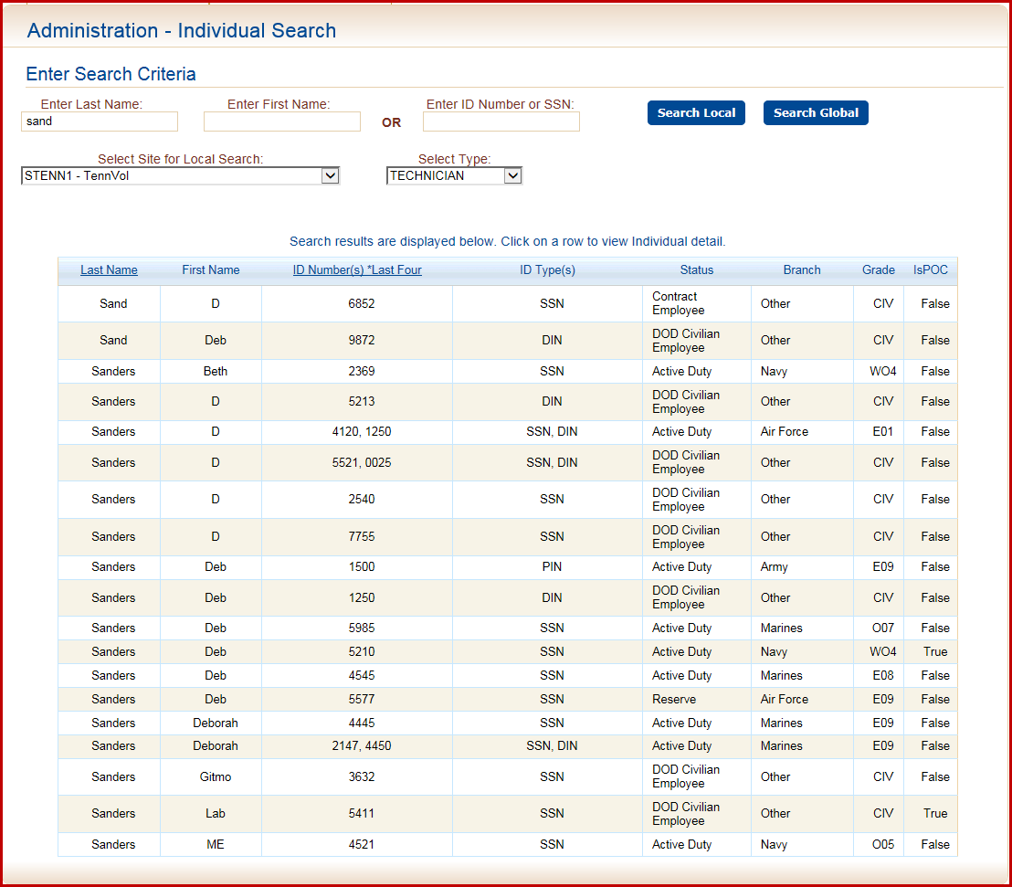

If the search specifies Technician as the Individual Type and the user clicks on the **Search Local** button, the system will display only the list of Technician that are loaded into their Lab in the SRTSweb database.



Click on a row to view detailed information about an Individual.

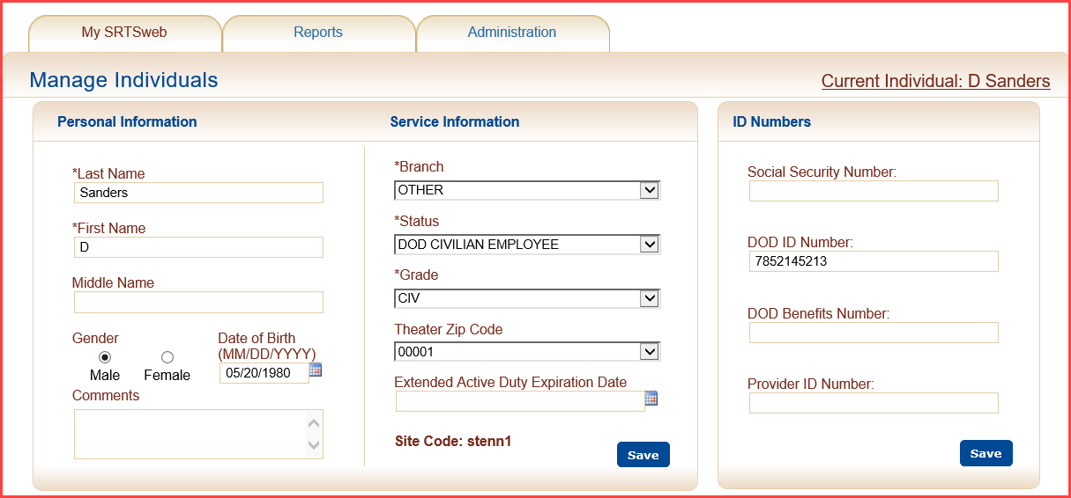

**Manage Individuals**

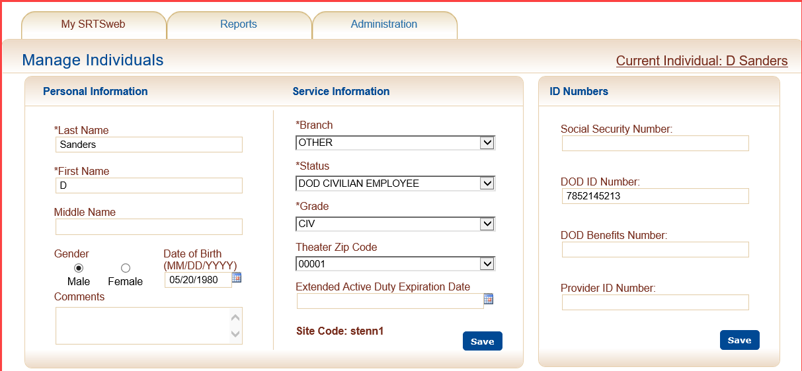

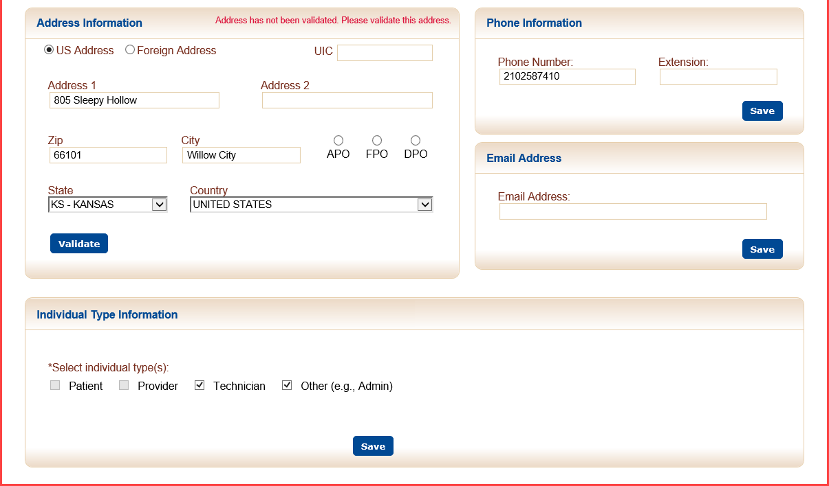

**Personal Information Service Information**

To update an individual’s **Personal and Service Information**, go to the Individual’s box that needs to be edited.

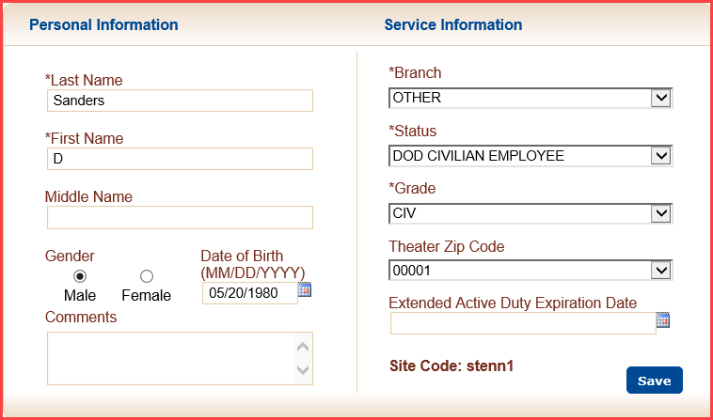

If the Personal Information is edited, click on the **Save** button to save the changes.

A confirmation message box will appear if any changes were made.

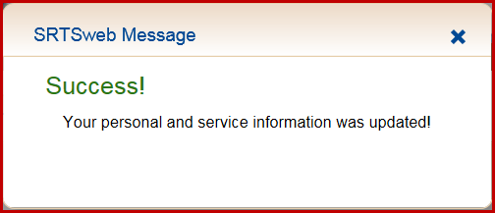

**ID Numbers**

An Identification Number record is automatically added when an Individual is initially added to the SRTSweb database. To add or update an existing Identification Number record for an individual, click on the Identification Number detail line.

Once the data has been entered, click the **Save** button to save the changes.

**NOTE:** A DOD ID Number has to be entered to register the CAC when adding a user.

### 

A confirmation message box will appear.

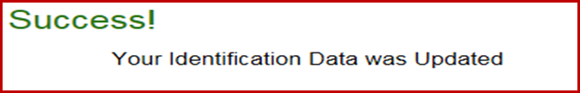

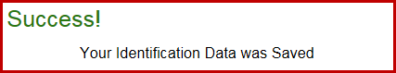

**Address Information**

To add or update an address record for an individual, select the Address Information box. Press **Validate** when complete.

The required fields to update a Mailing Address screen are:

* Address 1
* City
* State
* Zip Code - Will populate city, state and country appropriately.
* Country - The country will default to United States if applicable

The City will default if the APO, FPO or DPO are selected. State dropdowns will default to Area Europe (AE), Area Pacific (AP) or Area Atlantic (AA) for selection.

The address is only needed if glasses are to be ordered by a clinic and mailed to individual.

If a USPS validated address is selected, the address considered valid for 90 days. If a user overrides the USPS validation, the address is considered as valid for 30 days. If the address is a Foreign Address the address is considered valid for 30 days. A message will pop up after 30 or 90 days to say “Please validate this address”.

Address is compared against USPS data. If marked as "valid" through USPS, validation date is entered.

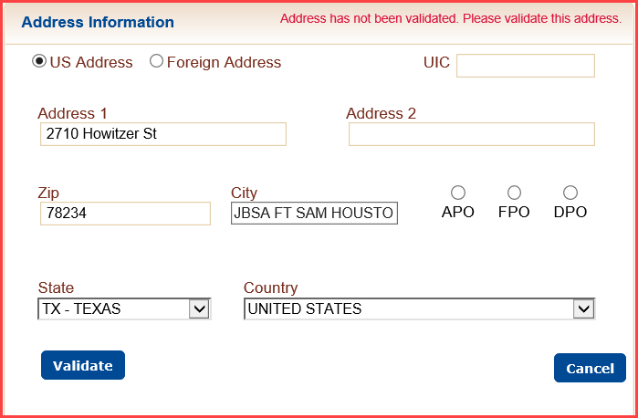

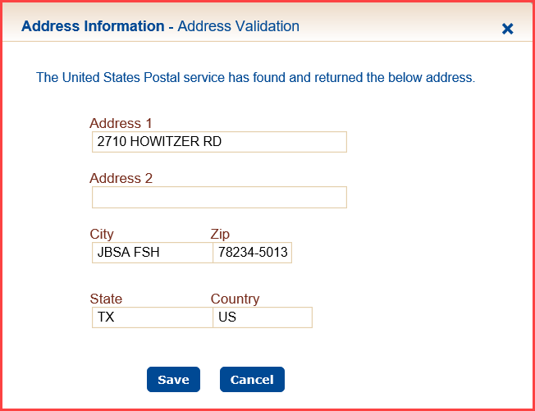

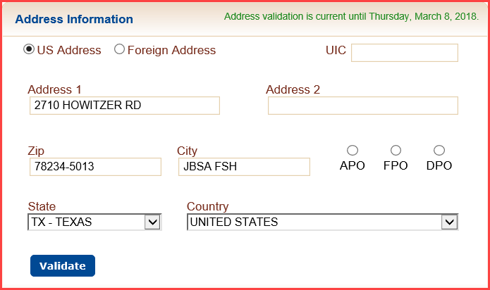

If not "valid", a window is presented with options to **Save Address as Entered** and be validated for 30 dates or **Cancel** to edit the address and validate again.

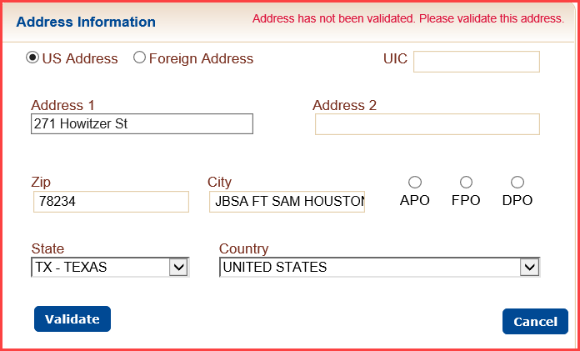

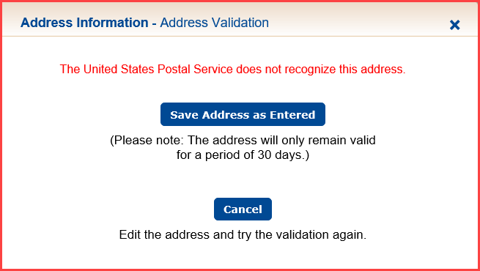

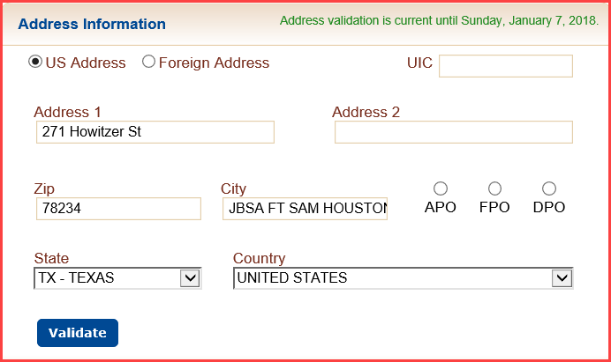

A confirmation message box will appear.

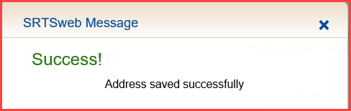

Selecting the Foreign Address gives the option to Address 1, Address 2 and Country.

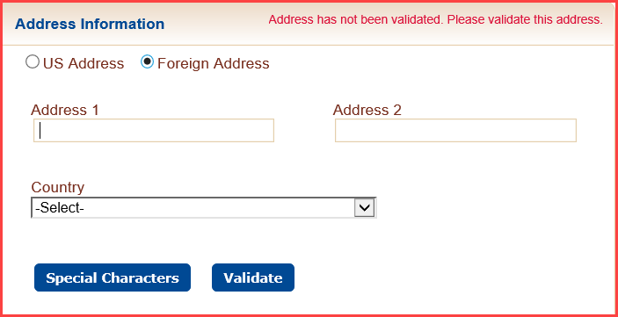

USPS can't validate foreign addresses, foreign addresses are treated differently. Validation process: Address is presumed valid after pressing **Validate**, and is valid for 30 days. After 30 days, the address popup says "Please validate this address".

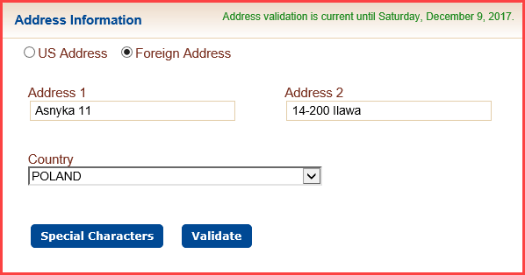

A SRTSweb confirmation message box will appear.

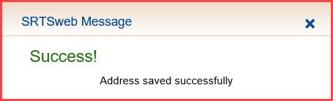

The user has the option of adding Non-English characters in the address field.

Press Special Characters.

Select character and press **Replace** or **Replace All**.

To **Replace** only one character highlight the character and press **Replace.**

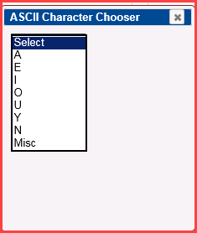

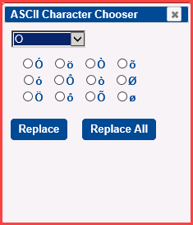

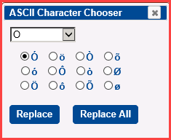

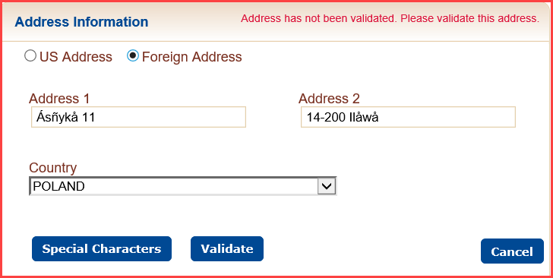

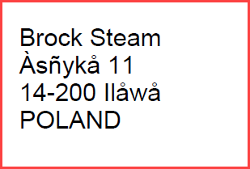

When the data entry is completed, click the **SAVE** button to save the record in the SRTSweb database.

A SRTSweb confirmation message box will appear.



**Phone Information**

To update an individual’s Phone Information, go to the Individual’s box that needs to be edited.

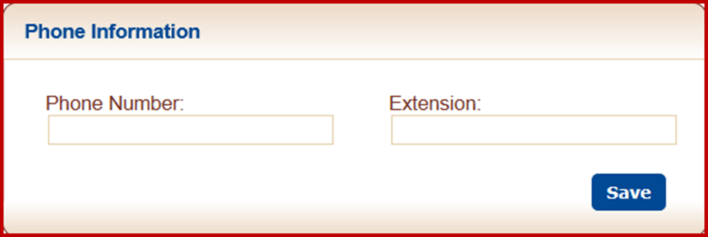

Once the data has been entered, click **Save** to save or update the phone record.

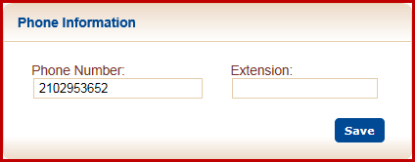

A confirmation message box will appear.

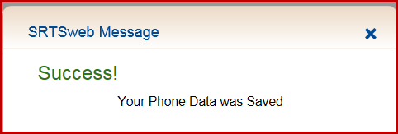

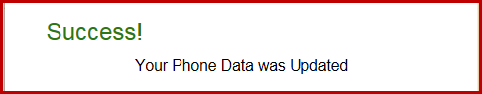

#### Email Address

To add or update an email for an individual, scroll to the Email Address Line.

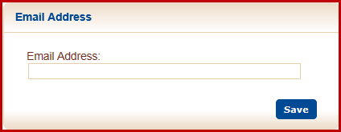

Once the data has been entered, click **Save** to save or edit the email address record.

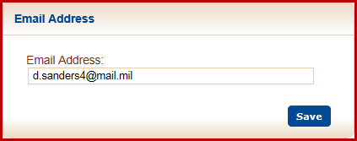

A confirmation message box will appear.

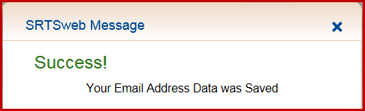

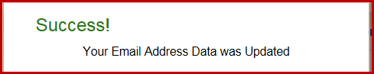

## Individual Type

To update an individual’s type (s), check or uncheck box and press **Save.**

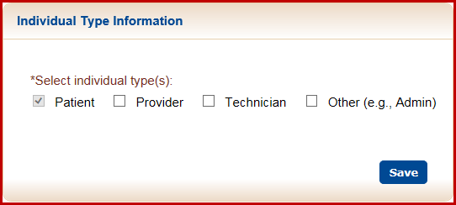

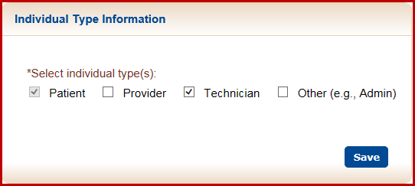

A confirmation message box will appear.

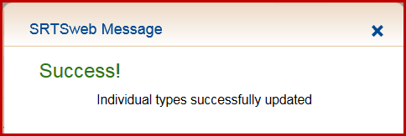

Clicking on the Individual’s name also will refresh the demographic from DMDC/DEERs to update. The data will show original data and refreshed data.

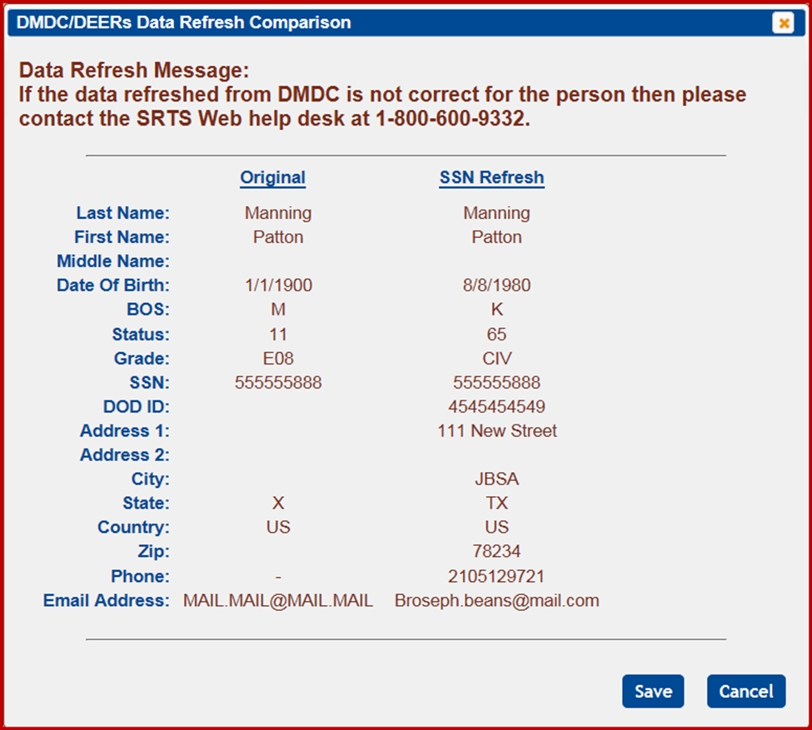

If no data is returned a message will appear.

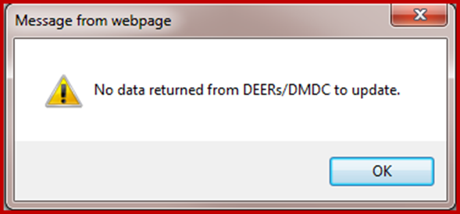

## Add Individual

## 

This screen allows the administrator to add a new individual to the SRTSweb database. An individual is not the same as a user. An individual is, basically, a description of someone that does some function in the Lab or Clinic. An individual is identified by type and those types are:

* Other – Admin
* Clerk
* Technician

Before a user’s profile can be added there must be an individual record built for them.

Required fields on the Enter New Individual Information screen are marked with an ‘*’ character.

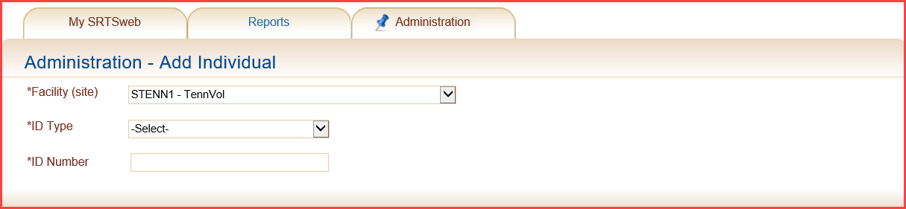

Valid Identification Number Types:

* DOD Benefits Number – 11 digits
* DOD ID Number – 10 digits
* Provider ID Number - 11 digits
* Social Security Number – 9 digits

If the Identification Number entered is already assigned to an Individual in the SRTSweb database, the screen will show a message “Person already exists in system, verify last 4 of their ID” and will display the individual information on file. Select the individual by clicking **View** on the individual name in the detail section.

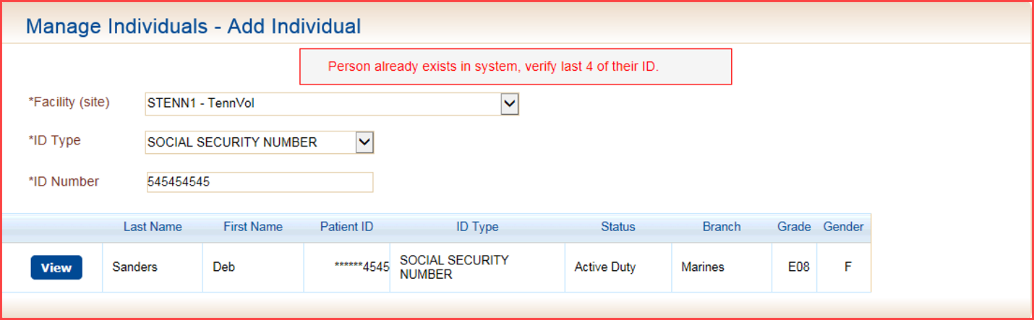

SRTSweb is linked with DMDC (DEERS) and will populate the individual’s information.

Select **Individual type** and update record as needed.

When the individual’s information has been entered, click on the **Submit** button to save the new individual record, or click on the **Cancel** button to return to the previous screen.

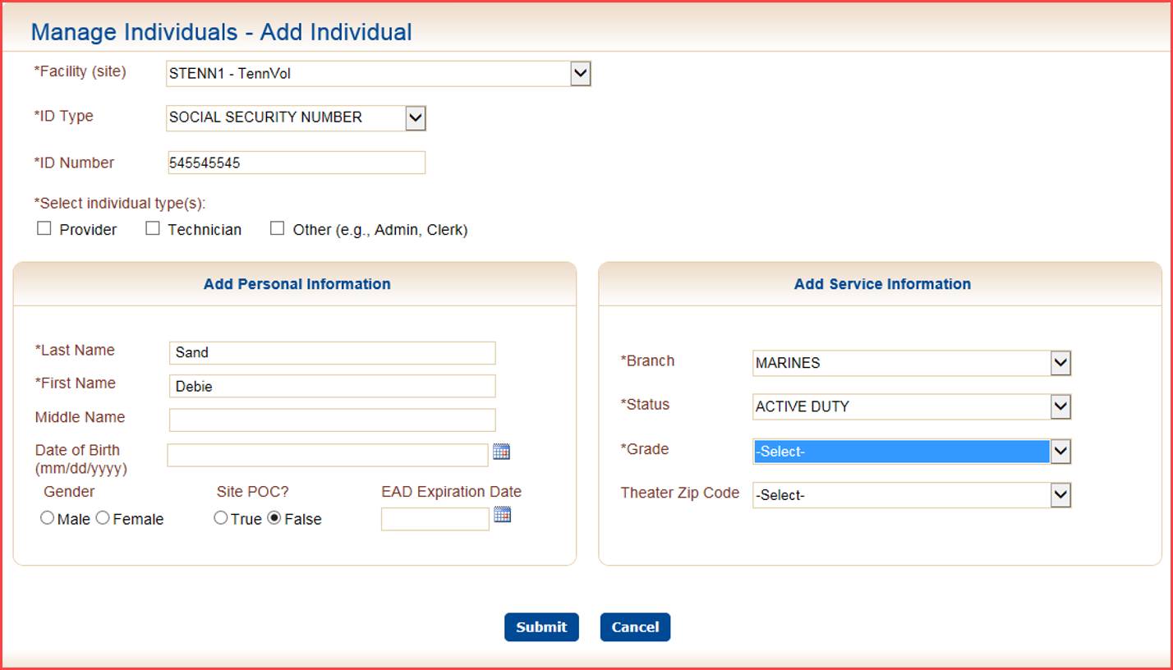

If no Individual Type is selected the user will get an error message.

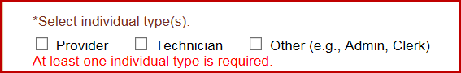

After submitting the new Individual record, the SRTSweb application goes to the Manage Individuals.

This screen allows you to add or edit Contact Information. The contact information is not required for an individual unless the individual will be placing orders for glasses.

The processes for editing the Manage Individuals screen are described in the **Individual Search** section of this User Guide.

**NOTE: Add the DOD ID Number. Adding the DOD will enable you to register the CAC for the user to log in with.**

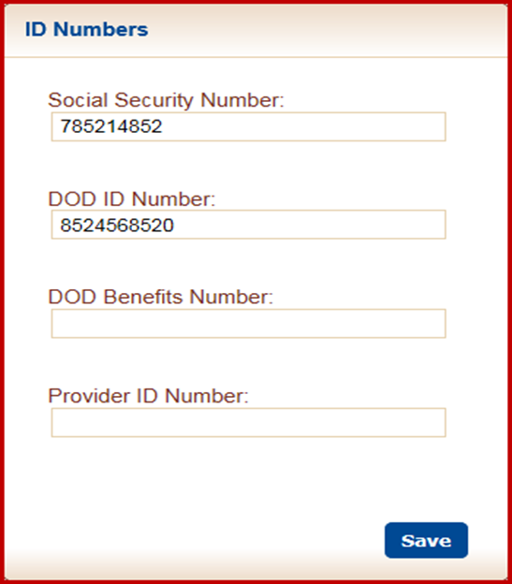

If the Identification Number does not show Individual information fill out the required fields.

Only the fields marked with “*” are required.

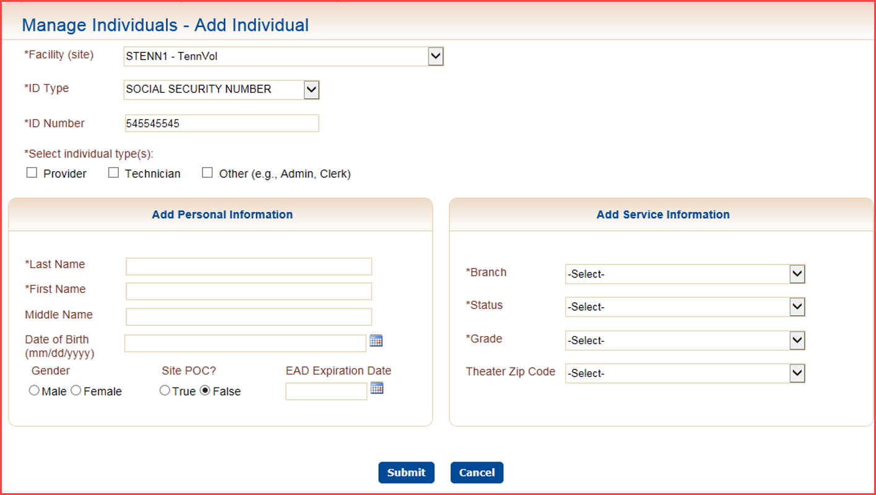

**SRTSweb Reports**

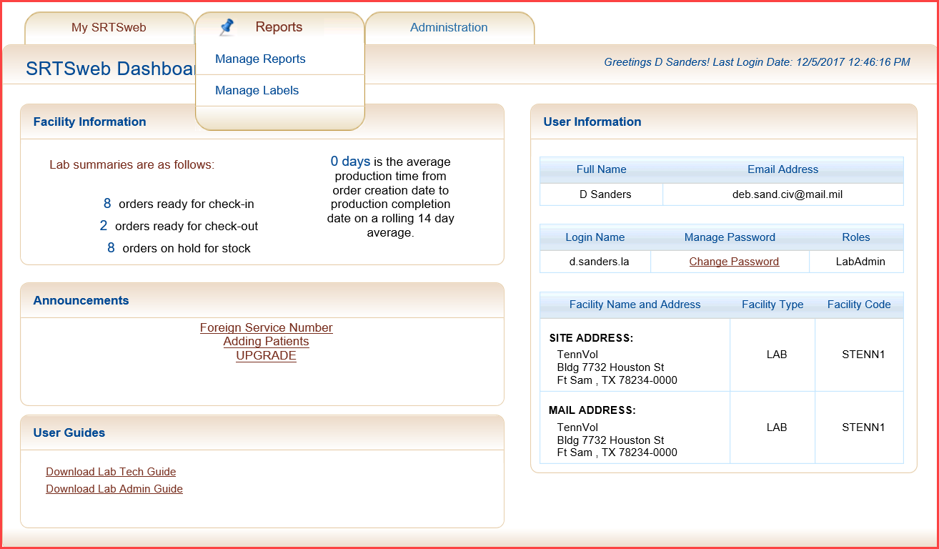

From the SRTSweb Dashboard screen, select My SRTSweb -> Report Manager.

The user may select a report to view from the drop down menu provided. The Lab module of SRTSweb may produce the following reports:

* Blank DD Form 771
* Reprint Lab Routing Forms
* Reprint Shipping Labels
* Report 54
* Patient 771

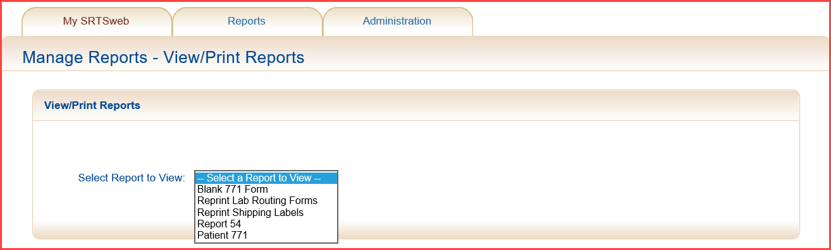

**Blank DD 771**



**Reprint Lab Routing Forms**



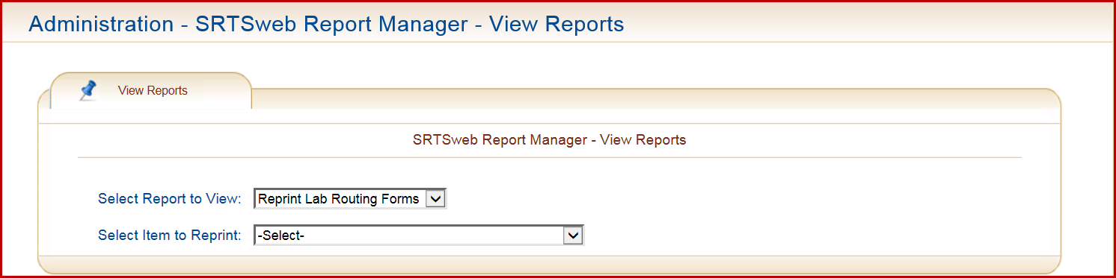

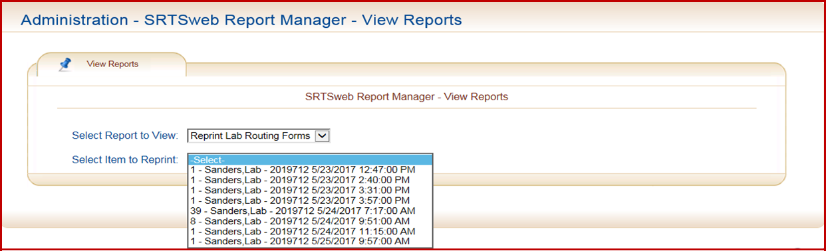

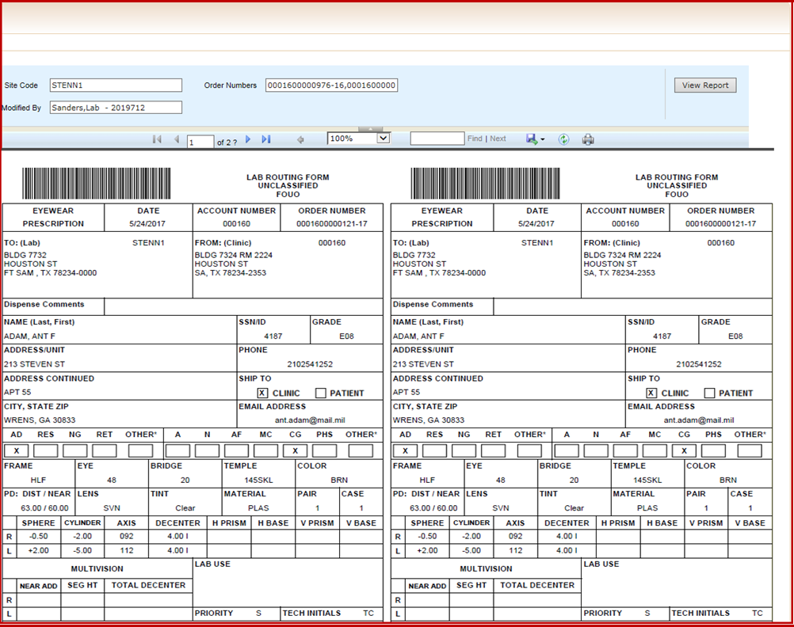

**Reprint Shipping Labels**

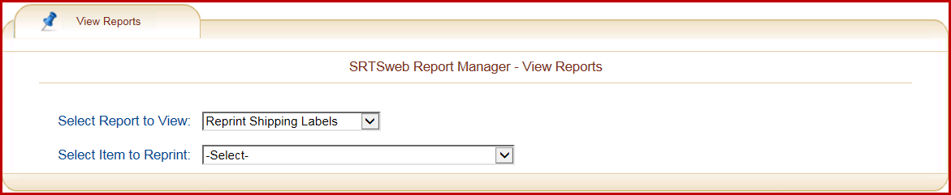

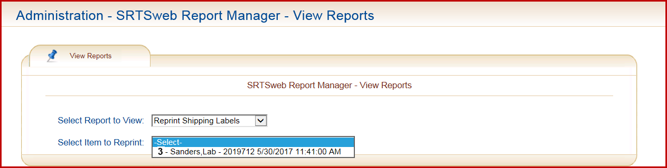

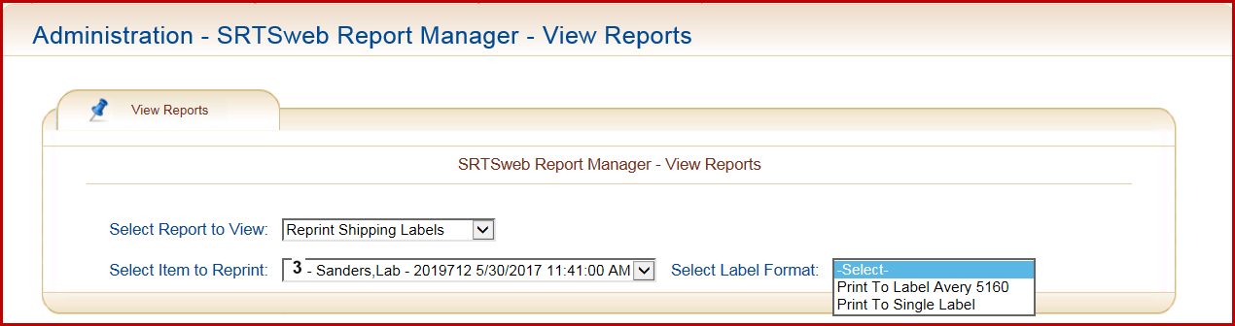

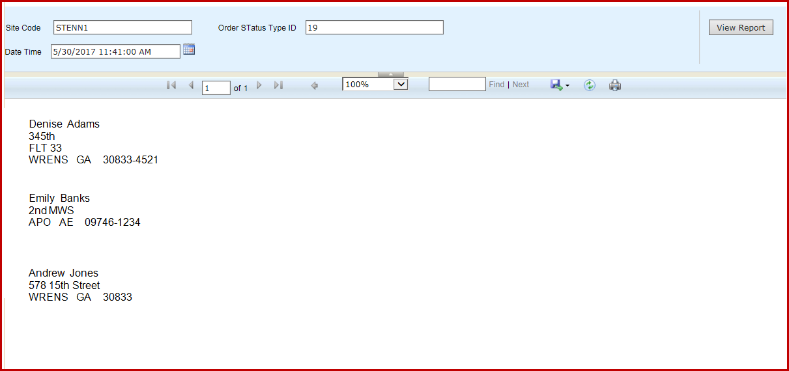

**Report 54**

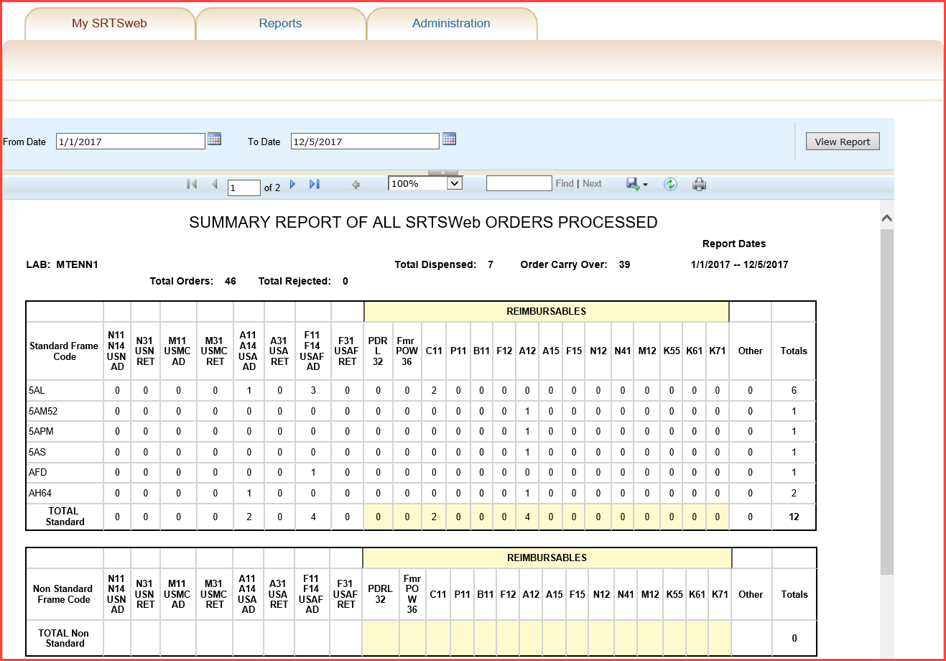

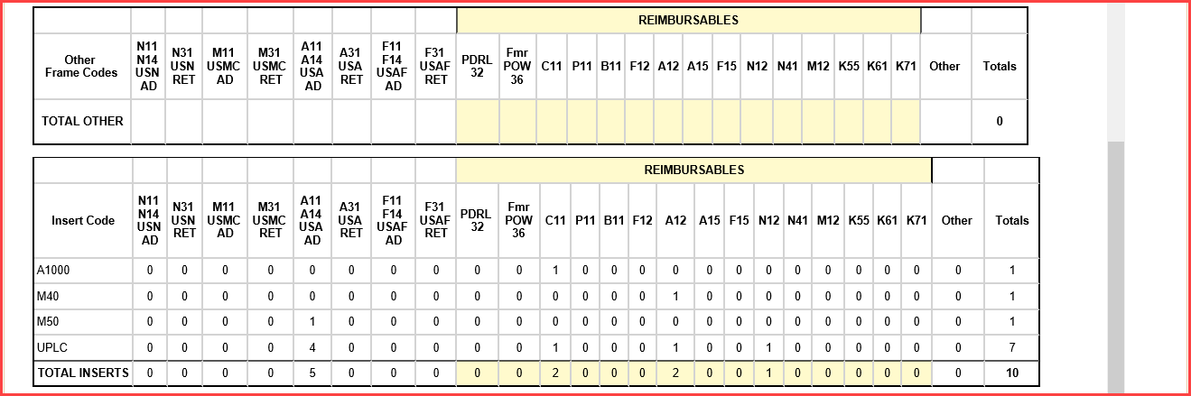

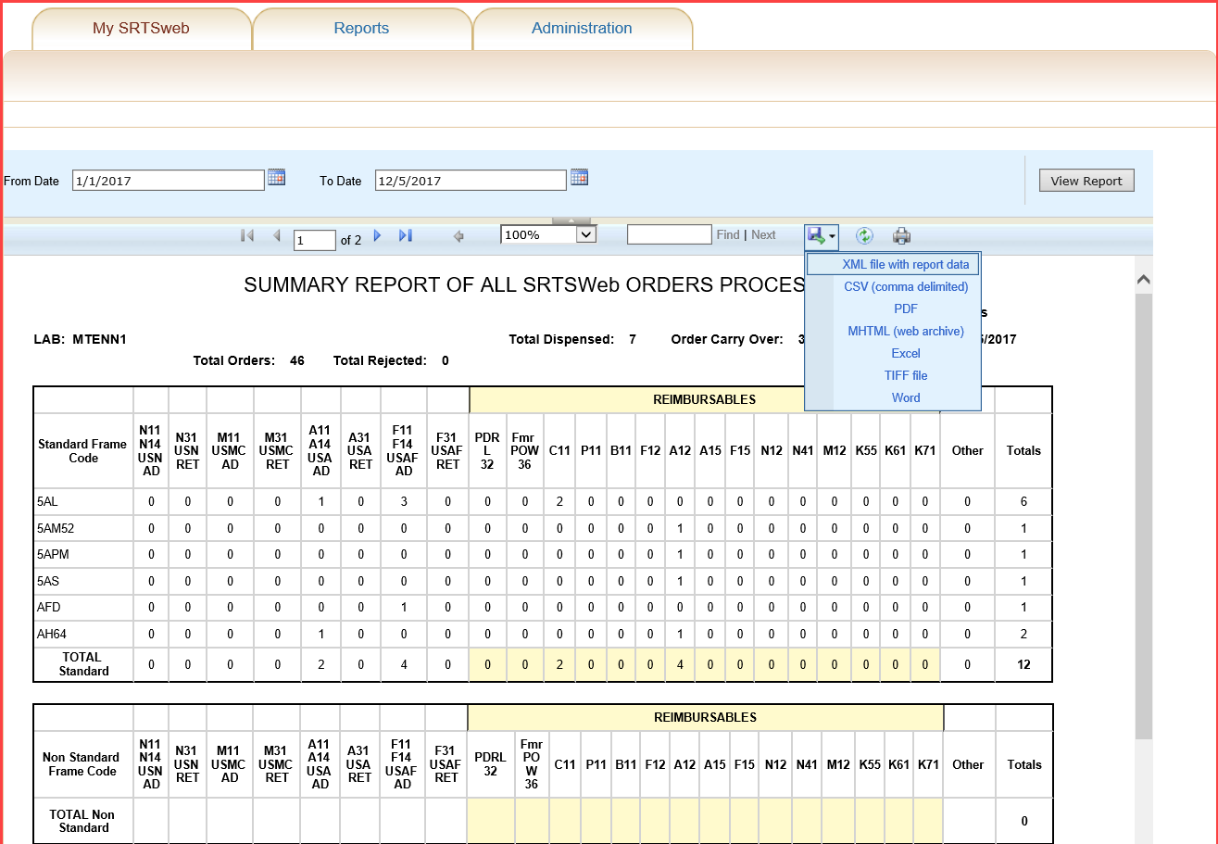

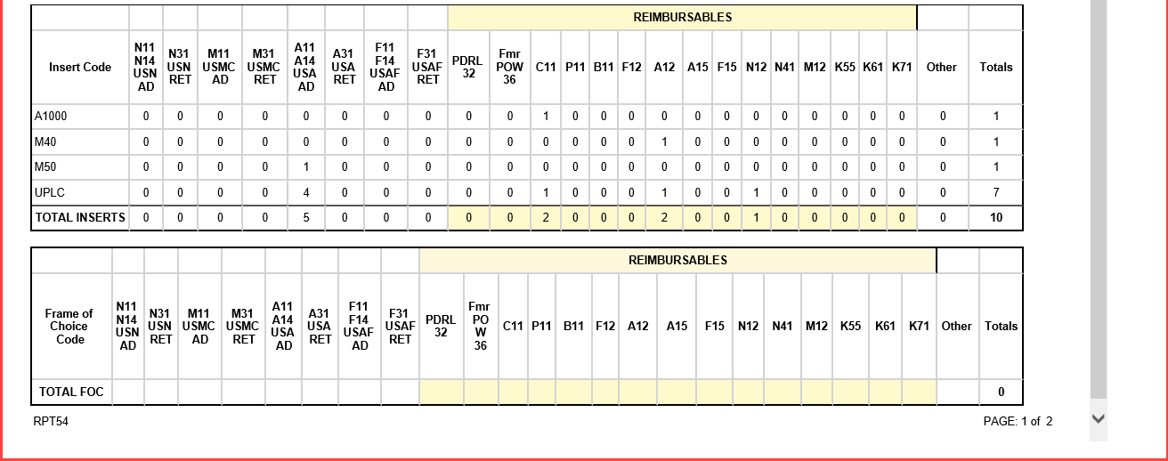



**Patient 771**